Yashwantrao Chavan Maharastra Open University


Chord Flow
By
Samuel Nazareth

Under the guidance of
Prof Arvind Singh

Submitted to the school of computer science, YCMOU in partial
Fulfilment of the requirement for award of the degree
Bachelor of Computer Application (BCA)



Smt. Durgadevi Sharma Charitable Trust’s Chandrabhan Sharma college of Arts, Commerece & Science
(Autonomous)
Hindi linguistic Minority Institution
(Affiliated to University of Mumbai)
NAAC RE-ACCCREDITED ‘A’ GRADE (CGPA 3.10)
MAY 2026




CERTIFICATE
This is to certify that the project report entitled Chord Flow submitted to Yashwantrao Chavan Maharashtra Open University in partial fulfilment of the requirement for the award of the degree of BACHELOR OF COMPUTER APPLICATIONS (BCA), is an authentic and original work carried out by Samuel Nazareth with PRN 02317000285994.

The matter embodied in this project is genuine work done by the student and has not been submitted whether to this University or to any other University / Institute for the fulfilment of the requirements of any course of study.

Project Guide Internal Examiner

Study Center Co - Ordinator

External Examiner

PRN:

Seal of Study Centre




CERTIFICATE OF COMPLETION
This is to certify that student of B.C.A has completed the Project Work titled " " under my guidance and supervision. The project report has been written according to the guidelines given by the Yashwantrao Chavan Maharashtra Open University

Project Guide Internal Examiner

Study Center Co - Ordinator

External Examiner

PRN:

Seal of Study Centre

ACKNOWLEDGEMENT
The successful completion of this project is the result of academic guidance, technical collaboration, and consistent encouragement from mentors, faculty members, friends, and family. We express our sincere gratitude to our project guide for providing direction during requirement analysis, design refinement, implementation, and verification.
We also thank the Department of B.C.A for creating an environment that encouraged careful documentation and practical system building. The feedback received during reviews helped transform an evolving software artifact into a disciplined engineering project with clearer architecture and better maintainability.
Special appreciation is extended to all contributors who assisted in data preparation, testing, interface observations, and domain understanding related to worship leadership workflows. Their operational insights ensured that the project remained useful in real ministry contexts rather than becoming a purely academic prototype.

PREFACE
This project titled “Chord Flow ” has been undertaken as a part of the Bachelor of Computer Applications (BCA) program. The motivation behind this project arose
from the practical challenges faced while accessing and presenting worship songs with properly aligned chords in a dig
ital format. Traditional methods often result in misalignment and inconsistent formatting, especially across different screen sizes.
During the development of this system, emphasis was placed on solving real-world problems through structured design and implementation. The project involved designing a system capable of dynamically rendering chords in alignment with lyrics, ensuring readability and consistency. This required careful consideration of data representation, rendering logic, and responsiveness.
The process of building this application has provided valuable insights into web-based system design, problem-solving, and the importance of maintaining both functional accuracy and user readability. It also offered an opportunity to apply theoretical concepts in a practical environment.
This report presents the work carried out, the challenges encountered, and the solutions implemented during the development of the system.

DECLARATION
I, Samuel Nazareth, hereby declare that the project titled “ChordFlow: Web-Based Worship Song System with Dynamic Chord Rendering” is my original work and has been prepared in partial fulfillment of the requirements for the Bachelor of Computer Applications (BCA) at Chandrabhan Sharma College.
The work presented in this project is based on my own study, analysis, and implementation. I take full responsibility for the accuracy, authenticity, and integrity of the content. All sources of information, references, and materials used have been properly acknowledged.
I further declare that this project has not been submitted, either in part or in full, for any other degree or examination at any other institution.
I understand the academic integrity policies of the institution and confirm that this work complies with all required ethical standards.

Contents
ACKNOWLEDGEMENT 4
PREFACE 5
DECLARATION 6
ABSTRACT 10
1.1 Background of the Study 12
1.2 Problem Statement 13
1.3 Objectives of the Project 13
1.4 Scope and Limitations 14
1.5 Significance of the Study 15
Chapter 2: Literature Survey 18
2.1 Digital Hymnal and Songbook Systems 18
2.2 Web-Based Content Retrieval Approaches 19
2.3 Multilingual Information Access 19
2.4 Chord Rendering Approaches 20
2.5 Research Gap 21
Chapter 3: Requirement Analysis 24
3.1 Functional Requirements 24
3.2 Non-Functional Requirements 25
3.3 User Roles and Use Cases 25
3.4 Feasibility Analysis 26
3.5 Risk Assessment 27
Chapter 4: System Design 30
4.1 Architectural Overview 31
4.2 Database Design 32
4.3 Module Decomposition 33
4.4 Data Flow and Control Boundaries 34
Chapter 5: Detailed Design of Chord Processing Pipeline 36
5.1 Input Formats and Parsing Strategy 39
5.2 Positional Chord Mapping 40
5.3 Structured Rendering Preparation 41
5.4 Error Handling in Chord Alignment 42
Chapter 6: User Interface and Layout Strategy 45
6.1 Interface Principles 46
6.2 Responsive Rendering Constraints 47
6.3 Margin-Based Alignment Philosophy 48
6.4 Accessibility and Readability 49
Chapter 7: Implementation of Core Modules 52
7.1 Servlet Layer 52
7.2 Service Layer 53
7.3 DAO Layer 53
7.4 Utility Components 54
Chapter 8: Database Implementation 57
8.1 Schema Realization 57
8.2 Seed Data Strategy 57
8.3 Integrity Constraints 58
8.4 Migration and Cleanup Considerations 59
Chapter 9: Search and Retrieval Engine 62
9.1 Numeric Search 62
9.2 Token-Based Text Search 62
9.3 Transliteration Support 63
9.4 Result Ranking and Filtering 64
Chapter 10: Testing and Validation 67
10.1 Unit Testing Strategy 67
10.2 Integration Testing 67
10.3 User Interface Validation 68
10.4 Defect Tracking and Resolution 69
Chapter 11: Performance, Reliability, and Security 72
11.1 Performance Objectives 72
11.2 Reliability Concerns 72
11.3 Session and Access Control 73
11.4 Data Quality Safeguards 74
Chapter 12: Deployment and Operational Workflow 77
12.1 Development Environment 77
12.2 Build and Deployment Pipeline 77
12.3 Administrative Operations 78
12.4 Maintenance Workflow 79
Chapter 13: Results and Discussion 82
13.1 Functional Outcomes 82
13.2 Comparative Improvement 82
13.3 Observed Challenges 83
13.4 Discussion 84
Chapter 14: Conclusion and Future Scope 87
14.1 Conclusion 87
14.2 Contribution Summary 88
14.3 Future Scope 88
14.4 Final Remarks 89
APPENDIX 92
A. Project File Highlights 92
B. Technology Stack 92
S 92

ABSTRACT
ChordFlow is a web-based worship song system designed to improve the accessibility and readability of song lyrics with accurately aligned chords. Traditional digital song formats often suffer from inconsistent chord positioning, especially across varying screen sizes and devices. This project addresses the challenge by implementing a dynamic chord rendering mechanism that maintains proper alignment between chords and corresponding lyrics.
The system processes song data using structured parsing and positional mapping techniques, enabling chords to be rendered relative to lyric text with consistency. A responsive layout strategy ensures that the alignment remains intact across different screen dimensions without distortion. The application also supports efficient song retrieval through numeric and text-based search mechanisms.
The system is developed using a layered architecture comprising servlet, service, and data access components, ensuring modularity and maintainability. Additionally, the database design supports structured storage and retrieval of multilingual song data.
ChordFlow demonstrates an effective approach to handling chord-lyric synchronization in web environments, improving usability for musicians and worship teams by providing a reliable and scalable digital song solution.

CHAPTER 1
INTRODUCTION

1.1 Background of the Study
The background of the study of the Worship Song Library was defined as an applied software engineering problem rather than a purely presentational web exercise. The project had to preserve lyrical meaning, support exact chord placement, and remain readable across desktop and mobile devices without relying on monospaced assumptions or manually inserted whitespace hacks.
From a project management perspective, the background of the study was shaped by the realities of worship ministry use. Songs are reused weekly, often transposed moments before performance, and sometimes searched in one language while sung in another. That operational context justified design decisions that prioritize retrieval speed, rendering stability, and maintainable content structure over purely decorative interface behavior.
The background of the study also reflects an academic emphasis on traceability. Every major feature in the system can be explained through inputs, transformations, persistence rules, and visible user outcomes. This makes the application suitable for documentation, maintenance, and future extension because the reasoning behind the architecture is explicit rather than accidental.
A recurring technical theme in the background of the study is separation of concerns. The system stores lyrics as stable textual content and treats chords as positional metadata, which reduces formatting brittleness and helps the same song render consistently under different screen widths, fonts, and accessibility constraints.
In evaluating the background of the study, the project team considered performance, correctness, editorial workflows, multilingual search behavior, and long-term data hygiene. Those dimensions are interconnected: a search system is only useful if data is structured correctly, and a rendering engine is only trustworthy if ingestion and storage rules maintain reliable positional indices.
The background of the study of the Worship Song Library was defined as an applied software engineering problem rather than a purely presentational web exercise. The project had to preserve lyrical meaning, support exact chord placement, and remain readable across desktop and mobile devices without relying on monospaced assumptions or manually inserted whitespace hacks.

1.2 Problem Statement
The problem statement of the Worship Song Library was defined as an applied software engineering problem rather than a purely presentational web exercise. The project had to preserve lyrical meaning, support exact chord placement, and remain readable across desktop and mobile devices without relying on monospaced assumptions or manually inserted whitespace hacks.
From a project management perspective, the problem statement was shaped by the realities of worship ministry use. Songs are reused weekly, often transposed moments before performance, and sometimes searched in one language while sung in another. That operational context justified design decisions that prioritize retrieval speed, rendering stability, and maintainable content structure over purely decorative interface behavior.
The problem statement also reflects an academic emphasis on traceability. Every major feature in the system can be explained through inputs, transformations, persistence rules, and visible user outcomes. This makes the application suitable for documentation, maintenance, and future extension because the reasoning behind the architecture is explicit rather than accidental.
A recurring technical theme in the problem statement is separation of concerns. The system stores lyrics as stable textual content and treats chords as positional metadata, which reduces formatting brittleness and helps the same song render consistently under different screen widths, fonts, and accessibility constraints.
In evaluating the problem statement, the project team considered performance, correctness, editorial workflows, multilingual search behavior, and long-term data hygiene. Those dimensions are interconnected: a search system is only useful if data is structured correctly, and a rendering engine is only trustworthy if ingestion and storage rules maintain reliable positional indices.

1.3 Objectives of the Project
The objectives of the project of the Worship Song Library was defined as an applied software engineering problem rather than a purely presentational web exercise. The project had to preserve lyrical meaning, support exact chord placement, and remain readable across desktop and mobile devices without relying on monospaced assumptions or manually inserted whitespace hacks.
From a project management perspective, the objectives of the project was shaped by the realities of worship ministry use. Songs are reused weekly, often transposed moments before performance, and sometimes searched in one language while sung in another. That operational context justified design decisions that prioritize retrieval speed, rendering stability, and maintainable content structure over purely decorative interface behavior.
The objectives of the project also reflects an academic emphasis on traceability. Every major feature in the system can be explained through inputs, transformations, persistence rules, and visible user outcomes. This makes the application suitable for documentation, maintenance, and future extension because the reasoning behind the architecture is explicit rather than accidental.
A recurring technical theme in the objectives of the project is separation of concerns. The system stores lyrics as stable textual content and treats chords as positional metadata, which reduces formatting brittleness and helps the same song render consistently under different screen widths, fonts, and accessibility constraints.
In evaluating the objectives of the project, the project team considered performance, correctness, editorial workflows, multilingual search behavior, and long-term data hygiene. Those dimensions are interconnected: a search system is only useful if data is structured correctly, and a rendering engine is only trustworthy if ingestion and storage rules maintain reliable positional indices.

1.4 Scope and Limitations
The scope and limitations of the Worship Song Library was defined as an applied software engineering problem rather than a purely presentational web exercise. The project had to preserve lyrical meaning, support exact chord placement, and remain readable across desktop and mobile devices without relying on monospaced assumptions or manually inserted whitespace hacks.
From a project management perspective, the scope and limitations was shaped by the realities of worship ministry use. Songs are reused weekly, often transposed moments before performance, and sometimes searched in one language while sung in another. That operational context justified design decisions that prioritize retrieval speed, rendering stability, and maintainable content structure over purely decorative interface behavior.
The scope and limitations also reflects an academic emphasis on traceability. Every major feature in the system can be explained through inputs, transformations, persistence rules, and visible user outcomes. This makes the application suitable for documentation, maintenance, and future extension because the reasoning behind the architecture is explicit rather than accidental.
A recurring technical theme in the scope and limitations is separation of concerns. The system stores lyrics as stable textual content and treats chords as positional metadata, which reduces formatting brittleness and helps the same song render consistently under different screen widths, fonts, and accessibility constraints.
In evaluating the scope and limitations, the project team considered performance, correctness, editorial workflows, multilingual search behavior, and long-term data hygiene. Those dimensions are interconnected: a search system is only useful if data is structured correctly, and a rendering engine is only trustworthy if ingestion and storage rules maintain reliable positional indices.

1.5 Significance of the Study
The significance of the study of the Worship Song Library was defined as an applied software engineering problem rather than a purely presentational web exercise. The project had to preserve lyrical meaning, support exact chord placement, and remain readable across desktop and mobile devices without relying on monospaced assumptions or manually inserted whitespace hacks.
From a project management perspective, the significance of the study was shaped by the realities of worship ministry use. Songs are reused weekly, often transposed moments before performance, and sometimes searched in one language while sung in another. That operational context justified design decisions that prioritize retrieval speed, rendering stability, and maintainable content structure over purely decorative interface behavior.
The significance of the study also reflects an academic emphasis on traceability. Every major feature in the system can be explained through inputs, transformations, persistence rules, and visible user outcomes. This makes the application suitable for documentation, maintenance, and future extension because the reasoning behind the architecture is explicit rather than accidental.
A recurring technical theme in the significance of the study is separation of concerns. The system stores lyrics as stable textual content and treats chords as positional metadata, which reduces formatting brittleness and helps the same song render consistently under different screen widths, fonts, and accessibility constraints.
In evaluating the significance of the study, the project team considered performance, correctness, editorial workflows, multilingual search behavior, and long-term data hygiene. Those dimensions are interconnected: a search system is only useful if data is structured correctly, and a rendering engine is only trustworthy if ingestion and storage rules maintain reliable positional indices.

CHAPTER 2
LITERATURE SURVEY

Chapter 2: Literature Survey

2.1 Digital Hymnal and Songbook Systems
The digital hymnal and songbook systems of the Worship Song Library was defined as an applied software engineering problem rather than a purely presentational web exercise. The project had to preserve lyrical meaning, support exact chord placement, and remain readable across desktop and mobile devices without relying on monospaced assumptions or manually inserted whitespace hacks.
From a project management perspective, the digital hymnal and songbook systems was shaped by the realities of worship ministry use. Songs are reused weekly, often transposed moments before performance, and sometimes searched in one language while sung in another. That operational context justified design decisions that prioritize retrieval speed, rendering stability, and maintainable content structure over purely decorative interface behavior.
The digital hymnal and songbook systems also reflects an academic emphasis on traceability. Every major feature in the system can be explained through inputs, transformations, persistence rules, and visible user outcomes. This makes the application suitable for documentation, maintenance, and future extension because the reasoning behind the architecture is explicit rather than accidental.
A recurring technical theme in the digital hymnal and songbook systems is separation of concerns. The system stores lyrics as stable textual content and treats chords as positional metadata, which reduces formatting brittleness and helps the same song render consistently under different screen widths, fonts, and accessibility constraints.
In evaluating the digital hymnal and songbook systems, the project team considered performance, correctness, editorial workflows, multilingual search behavior, and long-term data hygiene. Those dimensions are interconnected: a search system is only useful if data is structured correctly, and a rendering engine is only trustworthy if ingestion and storage rules maintain reliable positional indices.
The digital hymnal and songbook systems of the Worship Song Library was defined as an applied software engineering problem rather than a purely presentational web exercise. The project had to preserve lyrical meaning, support exact chord placement, and remain readable across desktop and mobile devices without relying on monospaced assumptions or manually inserted whitespace hacks.

2.2 Web-Based Content Retrieval Approaches
The web-based content retrieval approaches of the Worship Song Library was defined as an applied software engineering problem rather than a purely presentational web exercise. The project had to preserve lyrical meaning, support exact chord placement, and remain readable across desktop and mobile devices without relying on monospaced assumptions or manually inserted whitespace hacks.
From a project management perspective, the web-based content retrieval approaches was shaped by the realities of worship ministry use. Songs are reused weekly, often transposed moments before performance, and sometimes searched in one language while sung in another. That operational context justified design decisions that prioritize retrieval speed, rendering stability, and maintainable content structure over purely decorative interface behavior.
The web-based content retrieval approaches also reflects an academic emphasis on traceability. Every major feature in the system can be explained through inputs, transformations, persistence rules, and visible user outcomes. This makes the application suitable for documentation, maintenance, and future extension because the reasoning behind the architecture is explicit rather than accidental.
A recurring technical theme in the web-based content retrieval approaches is separation of concerns. The system stores lyrics as stable textual content and treats chords as positional metadata, which reduces formatting brittleness and helps the same song render consistently under different screen widths, fonts, and accessibility constraints.
In evaluating the web-based content retrieval approaches, the project team considered performance, correctness, editorial workflows, multilingual search behavior, and long-term data hygiene. Those dimensions are interconnected: a search system is only useful if data is structured correctly, and a rendering engine is only trustworthy if ingestion and storage rules maintain reliable positional indices.

2.3 Multilingual Information Access
The multilingual information access of the Worship Song Library was defined as an applied software engineering problem rather than a purely presentational web exercise. The project had to preserve lyrical meaning, support exact chord placement, and remain readable across desktop and mobile devices without relying on monospaced assumptions or manually inserted whitespace hacks.
From a project management perspective, the multilingual information access was shaped by the realities of worship ministry use. Songs are reused weekly, often transposed moments before performance, and sometimes searched in one language while sung in another. That operational context justified design decisions that prioritize retrieval speed, rendering stability, and maintainable content structure over purely decorative interface behavior.
The multilingual information access also reflects an academic emphasis on traceability. Every major feature in the system can be explained through inputs, transformations, persistence rules, and visible user outcomes. This makes the application suitable for documentation, maintenance, and future extension because the reasoning behind the architecture is explicit rather than accidental.
A recurring technical theme in the multilingual information access is separation of concerns. The system stores lyrics as stable textual content and treats chords as positional metadata, which reduces formatting brittleness and helps the same song render consistently under different screen widths, fonts, and accessibility constraints.
In evaluating the multilingual information access, the project team considered performance, correctness, editorial workflows, multilingual search behavior, and long-term data hygiene. Those dimensions are interconnected: a search system is only useful if data is structured correctly, and a rendering engine is only trustworthy if ingestion and storage rules maintain reliable positional indices.

2.4 Chord Rendering Approaches
The chord rendering approaches of the Worship Song Library was defined as an applied software engineering problem rather than a purely presentational web exercise. The project had to preserve lyrical meaning, support exact chord placement, and remain readable across desktop and mobile devices without relying on monospaced assumptions or manually inserted whitespace hacks.
From a project management perspective, the chord rendering approaches was shaped by the realities of worship ministry use. Songs are reused weekly, often transposed moments before performance, and sometimes searched in one language while sung in another. That operational context justified design decisions that prioritize retrieval speed, rendering stability, and maintainable content structure over purely decorative interface behavior.
The chord rendering approaches also reflects an academic emphasis on traceability. Every major feature in the system can be explained through inputs, transformations, persistence rules, and visible user outcomes. This makes the application suitable for documentation, maintenance, and future extension because the reasoning behind the architecture is explicit rather than accidental.
A recurring technical theme in the chord rendering approaches is separation of concerns. The system stores lyrics as stable textual content and treats chords as positional metadata, which reduces formatting brittleness and helps the same song render consistently under different screen widths, fonts, and accessibility constraints.
In evaluating the chord rendering approaches, the project team considered performance, correctness, editorial workflows, multilingual search behavior, and long-term data hygiene. Those dimensions are interconnected: a search system is only useful if data is structured correctly, and a rendering engine is only trustworthy if ingestion and storage rules maintain reliable positional indices.

2.5 Research Gap
The research gap of the Worship Song Library was defined as an applied software engineering problem rather than a purely presentational web exercise. The project had to preserve lyrical meaning, support exact chord placement, and remain readable across desktop and mobile devices without relying on monospaced assumptions or manually inserted whitespace hacks.
From a project management perspective, the research gap was shaped by the realities of worship ministry use. Songs are reused weekly, often transposed moments before performance, and sometimes searched in one language while sung in another. That operational context justified design decisions that prioritize retrieval speed, rendering stability, and maintainable content structure over purely decorative interface behavior.
The research gap also reflects an academic emphasis on traceability. Every major feature in the system can be explained through inputs, transformations, persistence rules, and visible user outcomes. This makes the application suitable for documentation, maintenance, and future extension because the reasoning behind the architecture is explicit rather than accidental.
A recurring technical theme in the research gap is separation of concerns. The system stores lyrics as stable textual content and treats chords as positional metadata, which reduces formatting brittleness and helps the same song render consistently under different screen widths, fonts, and accessibility constraints.
In evaluating the research gap, the project team considered performance, correctness, editorial workflows, multilingual search behavior, and long-term data hygiene. Those dimensions are interconnected: a search system is only useful if data is structured correctly, and a rendering engine is only trustworthy if ingestion and storage rules maintain reliable positional indices.

CHAPTER 3
REQUIREMENT ANALYSIS

Chapter 3: Requirement Analysis

3.1 Functional Requirements
The functional requirements of the Worship Song Library was defined as an applied software engineering problem rather than a purely presentational web exercise. The project had to preserve lyrical meaning, support exact chord placement, and remain readable across desktop and mobile devices without relying on monospaced assumptions or manually inserted whitespace hacks.
From a project management perspective, the functional requirements was shaped by the realities of worship ministry use. Songs are reused weekly, often transposed moments before performance, and sometimes searched in one language while sung in another. That operational context justified design decisions that prioritize retrieval speed, rendering stability, and maintainable content structure over purely decorative interface behavior.
The functional requirements also reflects an academic emphasis on traceability. Every major feature in the system can be explained through inputs, transformations, persistence rules, and visible user outcomes. This makes the application suitable for documentation, maintenance, and future extension because the reasoning behind the architecture is explicit rather than accidental.
A recurring technical theme in the functional requirements is separation of concerns. The system stores lyrics as stable textual content and treats chords as positional metadata, which reduces formatting brittleness and helps the same song render consistently under different screen widths, fonts, and accessibility constraints.
In evaluating the functional requirements, the project team considered performance, correctness, editorial workflows, multilingual search behavior, and long-term data hygiene. Those dimensions are interconnected: a search system is only useful if data is structured correctly, and a rendering engine is only trustworthy if ingestion and storage rules maintain reliable positional indices.
The functional requirements of the Worship Song Library was defined as an applied software engineering problem rather than a purely presentational web exercise. The project had to preserve lyrical meaning, support exact chord placement, and remain readable across desktop and mobile devices without relying on monospaced assumptions or manually inserted whitespace hacks.

3.2 Non-Functional Requirements
The non-functional requirements of the Worship Song Library was defined as an applied software engineering problem rather than a purely presentational web exercise. The project had to preserve lyrical meaning, support exact chord placement, and remain readable across desktop and mobile devices without relying on monospaced assumptions or manually inserted whitespace hacks.
From a project management perspective, the non-functional requirements was shaped by the realities of worship ministry use. Songs are reused weekly, often transposed moments before performance, and sometimes searched in one language while sung in another. That operational context justified design decisions that prioritize retrieval speed, rendering stability, and maintainable content structure over purely decorative interface behavior.
The non-functional requirements also reflects an academic emphasis on traceability. Every major feature in the system can be explained through inputs, transformations, persistence rules, and visible user outcomes. This makes the application suitable for documentation, maintenance, and future extension because the reasoning behind the architecture is explicit rather than accidental.
A recurring technical theme in the non-functional requirements is separation of concerns. The system stores lyrics as stable textual content and treats chords as positional metadata, which reduces formatting brittleness and helps the same song render consistently under different screen widths, fonts, and accessibility constraints.
In evaluating the non-functional requirements, the project team considered performance, correctness, editorial workflows, multilingual search behavior, and long-term data hygiene. Those dimensions are interconnected: a search system is only useful if data is structured correctly, and a rendering engine is only trustworthy if ingestion and storage rules maintain reliable positional indices.

3.3 User Roles and Use Cases
The user roles and use cases of the Worship Song Library was defined as an applied software engineering problem rather than a purely presentational web exercise. The project had to preserve lyrical meaning, support exact chord placement, and remain readable across desktop and mobile devices without relying on monospaced assumptions or manually inserted whitespace hacks.
From a project management perspective, the user roles and use cases was shaped by the realities of worship ministry use. Songs are reused weekly, often transposed moments before performance, and sometimes searched in one language while sung in another. That operational context justified design decisions that prioritize retrieval speed, rendering stability, and maintainable content structure over purely decorative interface behavior.
The user roles and use cases also reflects an academic emphasis on traceability. Every major feature in the system can be explained through inputs, transformations, persistence rules, and visible user outcomes. This makes the application suitable for documentation, maintenance, and future extension because the reasoning behind the architecture is explicit rather than accidental.
A recurring technical theme in the user roles and use cases is separation of concerns. The system stores lyrics as stable textual content and treats chords as positional metadata, which reduces formatting brittleness and helps the same song render consistently under different screen widths, fonts, and accessibility constraints.
In evaluating the user roles and use cases, the project team considered performance, correctness, editorial workflows, multilingual search behavior, and long-term data hygiene. Those dimensions are interconnected: a search system is only useful if data is structured correctly, and a rendering engine is only trustworthy if ingestion and storage rules maintain reliable positional indices.

3.4 Feasibility Analysis
The feasibility analysis of the Worship Song Library was defined as an applied software engineering problem rather than a purely presentational web exercise. The project had to preserve lyrical meaning, support exact chord placement, and remain readable across desktop and mobile devices without relying on monospaced assumptions or manually inserted whitespace hacks.
From a project management perspective, the feasibility analysis was shaped by the realities of worship ministry use. Songs are reused weekly, often transposed moments before performance, and sometimes searched in one language while sung in another. That operational context justified design decisions that prioritize retrieval speed, rendering stability, and maintainable content structure over purely decorative interface behavior.
The feasibility analysis also reflects an academic emphasis on traceability. Every major feature in the system can be explained through inputs, transformations, persistence rules, and visible user outcomes. This makes the application suitable for documentation, maintenance, and future extension because the reasoning behind the architecture is explicit rather than accidental.
A recurring technical theme in the feasibility analysis is separation of concerns. The system stores lyrics as stable textual content and treats chords as positional metadata, which reduces formatting brittleness and helps the same song render consistently under different screen widths, fonts, and accessibility constraints.
In evaluating the feasibility analysis, the project team considered performance, correctness, editorial workflows, multilingual search behavior, and long-term data hygiene. Those dimensions are interconnected: a search system is only useful if data is structured correctly, and a rendering engine is only trustworthy if ingestion and storage rules maintain reliable positional indices.

3.5 Risk Assessment
The risk assessment of the Worship Song Library was defined as an applied software engineering problem rather than a purely presentational web exercise. The project had to preserve lyrical meaning, support exact chord placement, and remain readable across desktop and mobile devices without relying on monospaced assumptions or manually inserted whitespace hacks.
From a project management perspective, the risk assessment was shaped by the realities of worship ministry use. Songs are reused weekly, often transposed moments before performance, and sometimes searched in one language while sung in another. That operational context justified design decisions that prioritize retrieval speed, rendering stability, and maintainable content structure over purely decorative interface behavior.
The risk assessment also reflects an academic emphasis on traceability. Every major feature in the system can be explained through inputs, transformations, persistence rules, and visible user outcomes. This makes the application suitable for documentation, maintenance, and future extension because the reasoning behind the architecture is explicit rather than accidental.
A recurring technical theme in the risk assessment is separation of concerns. The system stores lyrics as stable textual content and treats chords as positional metadata, which reduces formatting brittleness and helps the same song render consistently under different screen widths, fonts, and accessibility constraints.
In evaluating the risk assessment, the project team considered performance, correctness, editorial workflows, multilingual search behavior, and long-term data hygiene. Those dimensions are interconnected: a search system is only useful if data is structured correctly, and a rendering engine is only trustworthy if ingestion and storage rules maintain reliable positional indices.
Req. No. | Requirement | Category | Priority
FR-01 | Search songs by title, number, or lyrics | Functional | High
FR-02 | Render lyrics and chords responsively | Functional | High
FR-03 | Support multilingual song records | Functional | High
NFR-01 | Maintain alignment on mobile devices | Non-Functional | High
NFR-02 | Keep page response time within acceptable limits | Non-Functional | Medium

CHAPTER 4
SYSTEM DESIGN

Chapter 4: System Design
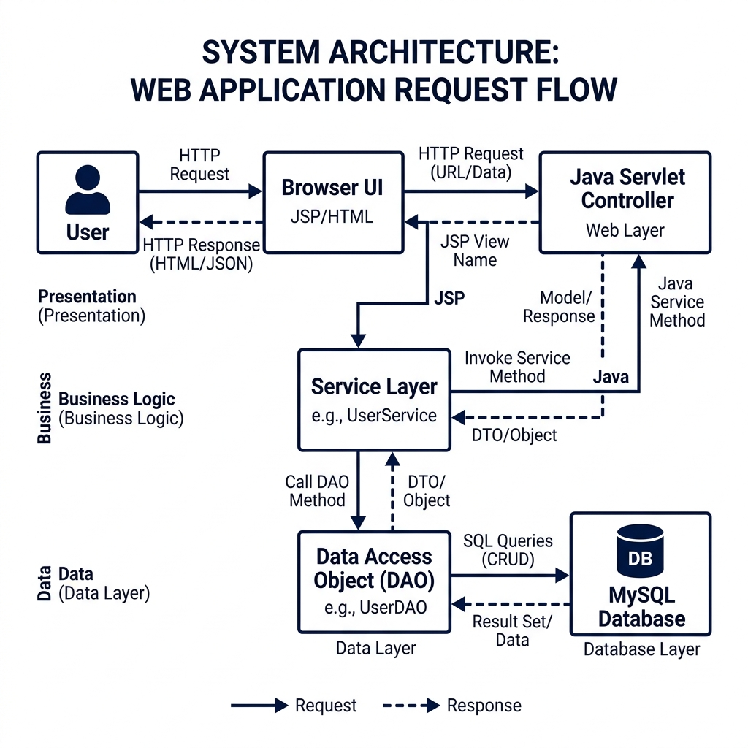
Figure 4.1 System Architecture of the Worship Song Library
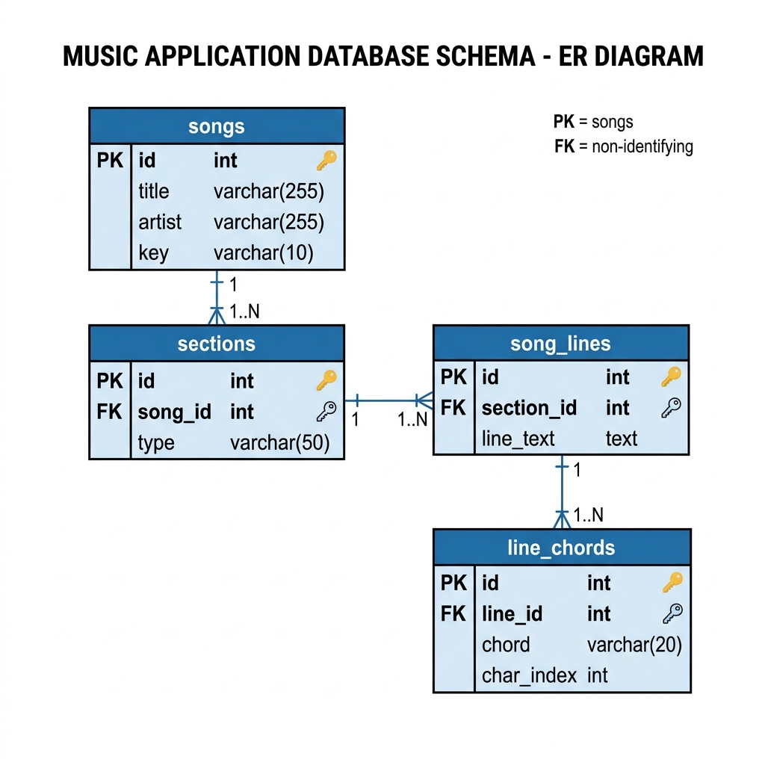
Figure 4.2 Entity Relationship Diagram of the Worship Song Library Database

4.1 Architectural Overview
The architectural overview of the Worship Song Library was defined as an applied software engineering problem rather than a purely presentational web exercise. The project had to preserve lyrical meaning, support exact chord placement, and remain readable across desktop and mobile devices without relying on monospaced assumptions or manually inserted whitespace hacks.
From a project management perspective, the architectural overview was shaped by the realities of worship ministry use. Songs are reused weekly, often transposed moments before performance, and sometimes searched in one language while sung in another. That operational context justified design decisions that prioritize retrieval speed, rendering stability, and maintainable content structure over purely decorative interface behavior.
The architectural overview also reflects an academic emphasis on traceability. Every major feature in the system can be explained through inputs, transformations, persistence rules, and visible user outcomes. This makes the application suitable for documentation, maintenance, and future extension because the reasoning behind the architecture is explicit rather than accidental.
A recurring technical theme in the architectural overview is separation of concerns. The system stores lyrics as stable textual content and treats chords as positional metadata, which reduces formatting brittleness and helps the same song render consistently under different screen widths, fonts, and accessibility constraints.
In evaluating the architectural overview, the project team considered performance, correctness, editorial workflows, multilingual search behavior, and long-term data hygiene. Those dimensions are interconnected: a search system is only useful if data is structured correctly, and a rendering engine is only trustworthy if ingestion and storage rules maintain reliable positional indices.

4.2 Database Design
The database design of the Worship Song Library was defined as an applied software engineering problem rather than a purely presentational web exercise. The project had to preserve lyrical meaning, support exact chord placement, and remain readable across desktop and mobile devices without relying on monospaced assumptions or manually inserted whitespace hacks.
From a project management perspective, the database design was shaped by the realities of worship ministry use. Songs are reused weekly, often transposed moments before performance, and sometimes searched in one language while sung in another. That operational context justified design decisions that prioritize retrieval speed, rendering stability, and maintainable content structure over purely decorative interface behavior.
The database design also reflects an academic emphasis on traceability. Every major feature in the system can be explained through inputs, transformations, persistence rules, and visible user outcomes. This makes the application suitable for documentation, maintenance, and future extension because the reasoning behind the architecture is explicit rather than accidental.
A recurring technical theme in the database design is separation of concerns. The system stores lyrics as stable textual content and treats chords as positional metadata, which reduces formatting brittleness and helps the same song render consistently under different screen widths, fonts, and accessibility constraints.
In evaluating the database design, the project team considered performance, correctness, editorial workflows, multilingual search behavior, and long-term data hygiene. Those dimensions are interconnected: a search system is only useful if data is structured correctly, and a rendering engine is only trustworthy if ingestion and storage rules maintain reliable positional indices.

4.3 Module Decomposition
The module decomposition of the Worship Song Library was defined as an applied software engineering problem rather than a purely presentational web exercise. The project had to preserve lyrical meaning, support exact chord placement, and remain readable across desktop and mobile devices without relying on monospaced assumptions or manually inserted whitespace hacks.
From a project management perspective, the module decomposition was shaped by the realities of worship ministry use. Songs are reused weekly, often transposed moments before performance, and sometimes searched in one language while sung in another. That operational context justified design decisions that prioritize retrieval speed, rendering stability, and maintainable content structure over purely decorative interface behavior.
The module decomposition also reflects an academic emphasis on traceability. Every major feature in the system can be explained through inputs, transformations, persistence rules, and visible user outcomes. This makes the application suitable for documentation, maintenance, and future extension because the reasoning behind the architecture is explicit rather than accidental.
A recurring technical theme in the module decomposition is separation of concerns. The system stores lyrics as stable textual content and treats chords as positional metadata, which reduces formatting brittleness and helps the same song render consistently under different screen widths, fonts, and accessibility constraints.
In evaluating the module decomposition, the project team considered performance, correctness, editorial workflows, multilingual search behavior, and long-term data hygiene. Those dimensions are interconnected: a search system is only useful if data is structured correctly, and a rendering engine is only trustworthy if ingestion and storage rules maintain reliable positional indices.

4.4 Data Flow and Control Boundaries
The data flow and control boundaries of the Worship Song Library was defined as an applied software engineering problem rather than a purely presentational web exercise. The project had to preserve lyrical meaning, support exact chord placement, and remain readable across desktop and mobile devices without relying on monospaced assumptions or manually inserted whitespace hacks.
From a project management perspective, the data flow and control boundaries was shaped by the realities of worship ministry use. Songs are reused weekly, often transposed moments before performance, and sometimes searched in one language while sung in another. That operational context justified design decisions that prioritize retrieval speed, rendering stability, and maintainable content structure over purely decorative interface behavior.
The data flow and control boundaries also reflects an academic emphasis on traceability. Every major feature in the system can be explained through inputs, transformations, persistence rules, and visible user outcomes. This makes the application suitable for documentation, maintenance, and future extension because the reasoning behind the architecture is explicit rather than accidental.
A recurring technical theme in the data flow and control boundaries is separation of concerns. The system stores lyrics as stable textual content and treats chords as positional metadata, which reduces formatting brittleness and helps the same song render consistently under different screen widths, fonts, and accessibility constraints.
In evaluating the data flow and control boundaries, the project team considered performance, correctness, editorial workflows, multilingual search behavior, and long-term data hygiene. Those dimensions are interconnected: a search system is only useful if data is structured correctly, and a rendering engine is only trustworthy if ingestion and storage rules maintain reliable positional indices.

CHAPTER 5
DETAILED DESIGN OF CHORD PROCESSING PIPELINE

Chapter 5: Detailed Design of Chord Processing Pipeline
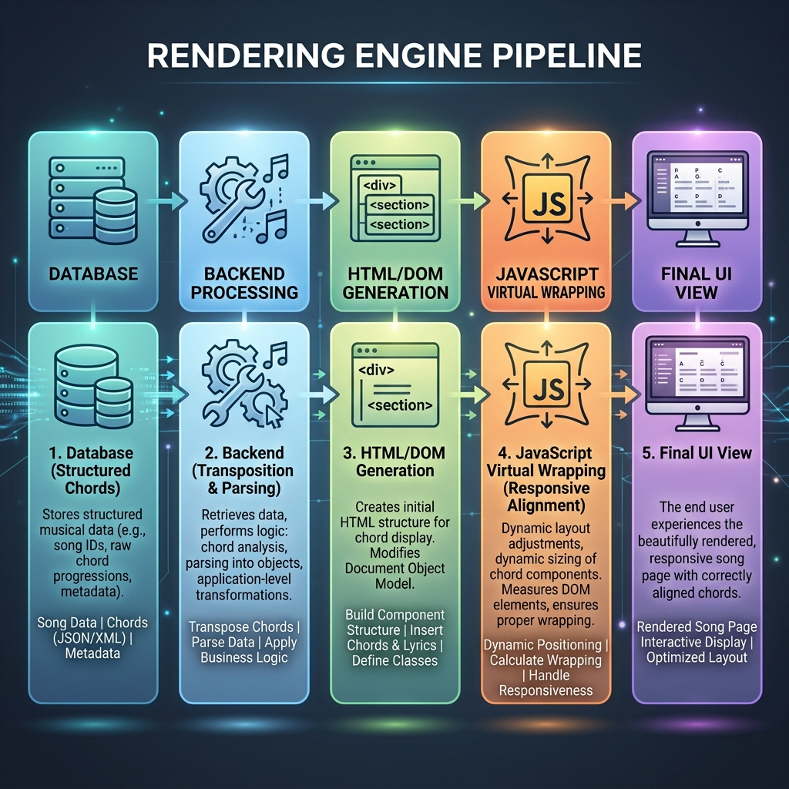
Figure 5.1 Rendering Flow from Request to Structured Output
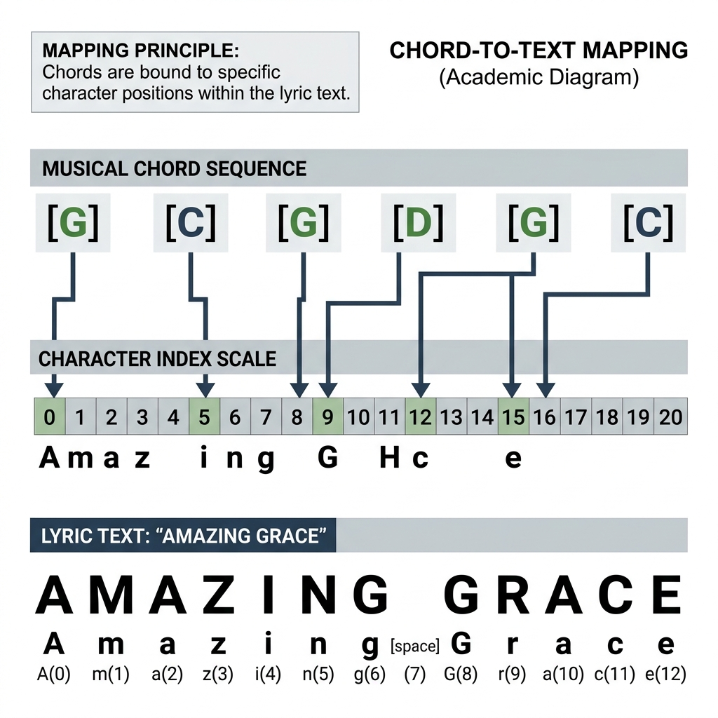
Figure 5.2 Chord-to-Text Mapping Using Character Index Positions
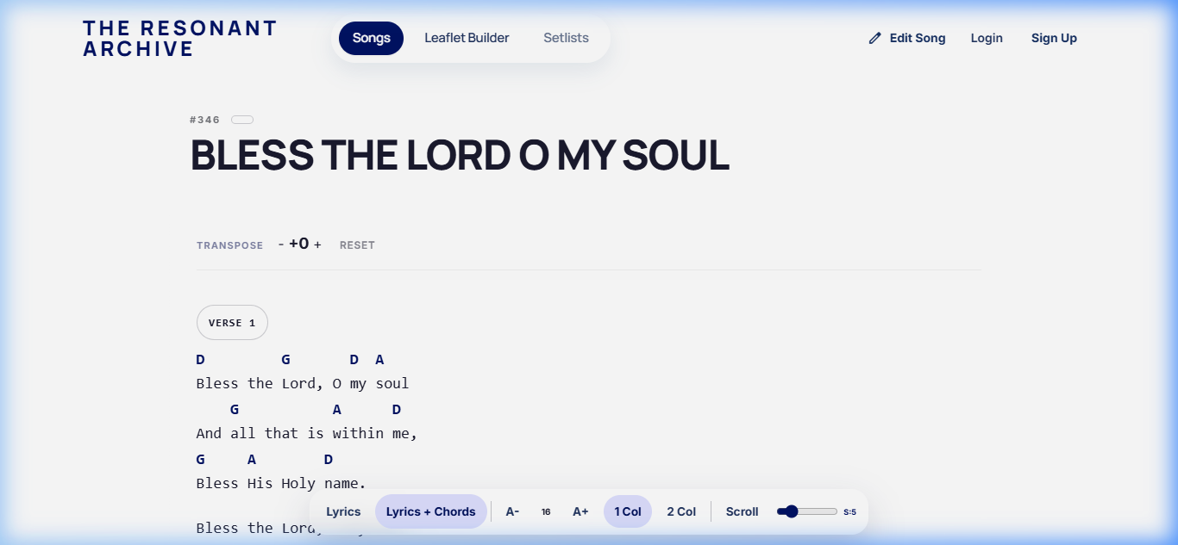
This screenshot shows the final rendered song view after structured lyric lines and chord occurrences have been fetched from the relational model and transformed into display-ready spans. Chords are not stored as padded text; they are attached to character positions and rendered above the corresponding lyric fragments during HTML generation. The visible alignment confirms that the rendering layer is reconstructing positional metadata at runtime rather than replaying a static preformatted chord sheet. This behavior is produced by the same mapping pipeline that converts database line records into anchored visual blocks before the browser applies responsive layout rules.
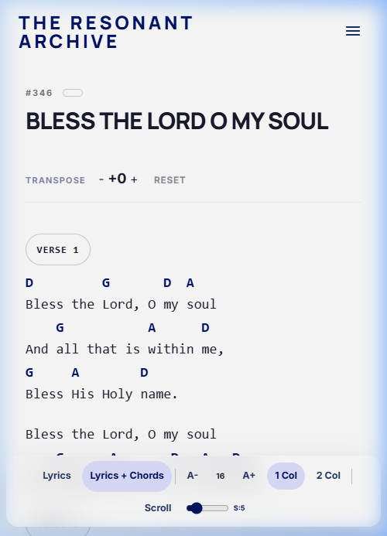
This image captures the wrapping stage where the client-side layout engine splits an overlong rendered line into smaller visual segments once the available width is exceeded. During this operation, the JavaScript wrapping routine recalculates the local offsets of every chord token so that each chord remains bound to the correct substring after the break point changes. The screenshot therefore reflects dynamic restructuring of one logical line into multiple rendered lines without mutating the stored lyric text. It directly corresponds to the implementation logic that preserves mapping correctness while adapting to viewport constraints in real time.
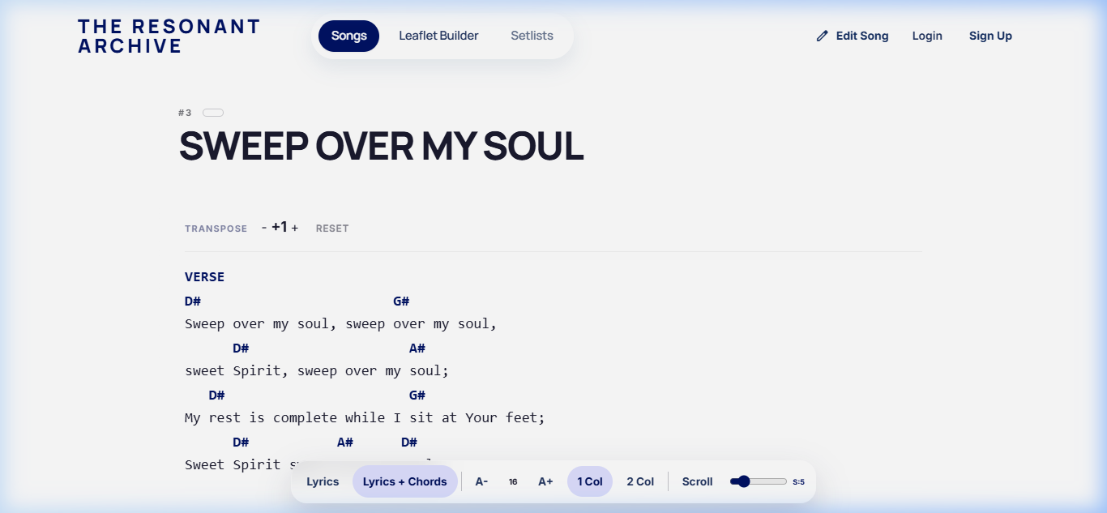
This screenshot demonstrates dynamic chord transformation after the rendering structure has already been built, indicating that the system updates musical values while preserving the existing lyric-to-position relationships. The visible change is driven by transposition logic that rewrites chord symbols mathematically from the underlying chord sequence rather than by manually editing displayed text. Because the lyric nodes and chord anchors remain stable, the transformed output retains the same structural alignment after recalculation. The behavior validates the separation between immutable lyric content, stored positional metadata, and runtime chord conversion logic.

5.1 Input Formats and Parsing Strategy
The input formats and parsing strategy of the Worship Song Library was defined as an applied software engineering problem rather than a purely presentational web exercise. The project had to preserve lyrical meaning, support exact chord placement, and remain readable across desktop and mobile devices without relying on monospaced assumptions or manually inserted whitespace hacks.
From a project management perspective, the input formats and parsing strategy was shaped by the realities of worship ministry use. Songs are reused weekly, often transposed moments before performance, and sometimes searched in one language while sung in another. That operational context justified design decisions that prioritize retrieval speed, rendering stability, and maintainable content structure over purely decorative interface behavior.
The input formats and parsing strategy also reflects an academic emphasis on traceability. Every major feature in the system can be explained through inputs, transformations, persistence rules, and visible user outcomes. This makes the application suitable for documentation, maintenance, and future extension because the reasoning behind the architecture is explicit rather than accidental.
A recurring technical theme in the input formats and parsing strategy is separation of concerns. The system stores lyrics as stable textual content and treats chords as positional metadata, which reduces formatting brittleness and helps the same song render consistently under different screen widths, fonts, and accessibility constraints.
In evaluating the input formats and parsing strategy, the project team considered performance, correctness, editorial workflows, multilingual search behavior, and long-term data hygiene. Those dimensions are interconnected: a search system is only useful if data is structured correctly, and a rendering engine is only trustworthy if ingestion and storage rules maintain reliable positional indices.
The input formats and parsing strategy of the Worship Song Library was defined as an applied software engineering problem rather than a purely presentational web exercise. The project had to preserve lyrical meaning, support exact chord placement, and remain readable across desktop and mobile devices without relying on monospaced assumptions or manually inserted whitespace hacks.

5.2 Positional Chord Mapping
The positional chord mapping of the Worship Song Library was defined as an applied software engineering problem rather than a purely presentational web exercise. The project had to preserve lyrical meaning, support exact chord placement, and remain readable across desktop and mobile devices without relying on monospaced assumptions or manually inserted whitespace hacks.
From a project management perspective, the positional chord mapping was shaped by the realities of worship ministry use. Songs are reused weekly, often transposed moments before performance, and sometimes searched in one language while sung in another. That operational context justified design decisions that prioritize retrieval speed, rendering stability, and maintainable content structure over purely decorative interface behavior.
The positional chord mapping also reflects an academic emphasis on traceability. Every major feature in the system can be explained through inputs, transformations, persistence rules, and visible user outcomes. This makes the application suitable for documentation, maintenance, and future extension because the reasoning behind the architecture is explicit rather than accidental.
A recurring technical theme in the positional chord mapping is separation of concerns. The system stores lyrics as stable textual content and treats chords as positional metadata, which reduces formatting brittleness and helps the same song render consistently under different screen widths, fonts, and accessibility constraints.
In evaluating the positional chord mapping, the project team considered performance, correctness, editorial workflows, multilingual search behavior, and long-term data hygiene. Those dimensions are interconnected: a search system is only useful if data is structured correctly, and a rendering engine is only trustworthy if ingestion and storage rules maintain reliable positional indices.

5.3 Structured Rendering Preparation
The structured rendering preparation of the Worship Song Library was defined as an applied software engineering problem rather than a purely presentational web exercise. The project had to preserve lyrical meaning, support exact chord placement, and remain readable across desktop and mobile devices without relying on monospaced assumptions or manually inserted whitespace hacks.
From a project management perspective, the structured rendering preparation was shaped by the realities of worship ministry use. Songs are reused weekly, often transposed moments before performance, and sometimes searched in one language while sung in another. That operational context justified design decisions that prioritize retrieval speed, rendering stability, and maintainable content structure over purely decorative interface behavior.
The structured rendering preparation also reflects an academic emphasis on traceability. Every major feature in the system can be explained through inputs, transformations, persistence rules, and visible user outcomes. This makes the application suitable for documentation, maintenance, and future extension because the reasoning behind the architecture is explicit rather than accidental.
A recurring technical theme in the structured rendering preparation is separation of concerns. The system stores lyrics as stable textual content and treats chords as positional metadata, which reduces formatting brittleness and helps the same song render consistently under different screen widths, fonts, and accessibility constraints.
In evaluating the structured rendering preparation, the project team considered performance, correctness, editorial workflows, multilingual search behavior, and long-term data hygiene. Those dimensions are interconnected: a search system is only useful if data is structured correctly, and a rendering engine is only trustworthy if ingestion and storage rules maintain reliable positional indices.

5.4 Error Handling in Chord Alignment
The error handling in chord alignment of the Worship Song Library was defined as an applied software engineering problem rather than a purely presentational web exercise. The project had to preserve lyrical meaning, support exact chord placement, and remain readable across desktop and mobile devices without relying on monospaced assumptions or manually inserted whitespace hacks.
From a project management perspective, the error handling in chord alignment was shaped by the realities of worship ministry use. Songs are reused weekly, often transposed moments before performance, and sometimes searched in one language while sung in another. That operational context justified design decisions that prioritize retrieval speed, rendering stability, and maintainable content structure over purely decorative interface behavior.
The error handling in chord alignment also reflects an academic emphasis on traceability. Every major feature in the system can be explained through inputs, transformations, persistence rules, and visible user outcomes. This makes the application suitable for documentation, maintenance, and future extension because the reasoning behind the architecture is explicit rather than accidental.
A recurring technical theme in the error handling in chord alignment is separation of concerns. The system stores lyrics as stable textual content and treats chords as positional metadata, which reduces formatting brittleness and helps the same song render consistently under different screen widths, fonts, and accessibility constraints.
In evaluating the error handling in chord alignment, the project team considered performance, correctness, editorial workflows, multilingual search behavior, and long-term data hygiene. Those dimensions are interconnected: a search system is only useful if data is structured correctly, and a rendering engine is only trustworthy if ingestion and storage rules maintain reliable positional indices.

CHAPTER 6
USER INTERFACE AND LAYOUT STRATEGY

Chapter 6: User Interface and Layout Strategy
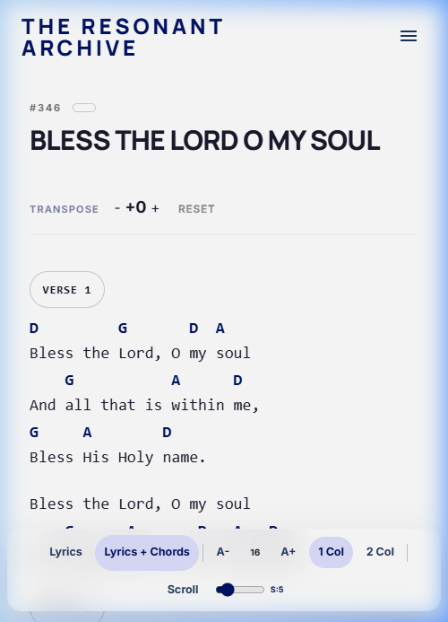
This screenshot shows the same rendered song content adapting across different viewport widths while maintaining the relative relationship between lyric segments and their associated chord markers. Internally, the browser receives the same structured data model, but the wrapping algorithm recomputes visual breaks so that alignment survives changes in available horizontal space. The stable chord placement confirms that layout responsiveness operates on anchored positions instead of whitespace formatting assumptions. It therefore serves as evidence that the rendering pipeline remains deterministic across responsive states generated from one backend representation.

This mobile view confirms that the structured rendering strategy remains correct even when the display width is constrained to a narrow handheld form factor. The visible chord placement indicates that line segmentation and chord re-anchoring are recalculated for the small screen while the original song structure, line order, and positional indices remain unchanged in storage. Rather than compressing a desktop chord sheet, the system rebuilds the visual arrangement from normalized line and chord data for the target device width. The screenshot therefore validates cross-device consistency between database mapping, servlet output, and client-side responsive rendering logic.
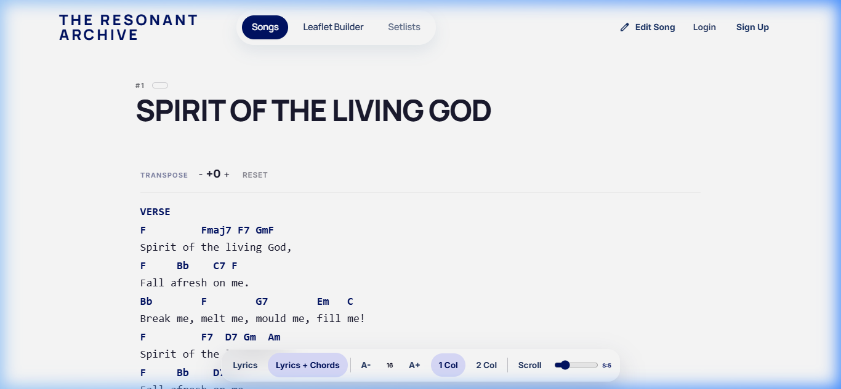
This screenshot illustrates a more difficult alignment case in which dense chord placement and irregular lyric segmentation must still resolve into a readable synchronized output. The system handles such edge cases by processing each chord occurrence as indexed metadata and then redistributing those anchors when the line is wrapped or reflowed for the current viewport. What is visible is not a manually tuned exception, but the result of generalized mapping logic applied to a higher-complexity input pattern. The preserved correspondence between chords and lyric fragments demonstrates that the implementation can absorb alignment stress without falling back to fixed-width text formatting.

6.1 Interface Principles
The interface principles of the Worship Song Library was defined as an applied software engineering problem rather than a purely presentational web exercise. The project had to preserve lyrical meaning, support exact chord placement, and remain readable across desktop and mobile devices without relying on monospaced assumptions or manually inserted whitespace hacks.
From a project management perspective, the interface principles was shaped by the realities of worship ministry use. Songs are reused weekly, often transposed moments before performance, and sometimes searched in one language while sung in another. That operational context justified design decisions that prioritize retrieval speed, rendering stability, and maintainable content structure over purely decorative interface behavior.
The interface principles also reflects an academic emphasis on traceability. Every major feature in the system can be explained through inputs, transformations, persistence rules, and visible user outcomes. This makes the application suitable for documentation, maintenance, and future extension because the reasoning behind the architecture is explicit rather than accidental.
A recurring technical theme in the interface principles is separation of concerns. The system stores lyrics as stable textual content and treats chords as positional metadata, which reduces formatting brittleness and helps the same song render consistently under different screen widths, fonts, and accessibility constraints.
In evaluating the interface principles, the project team considered performance, correctness, editorial workflows, multilingual search behavior, and long-term data hygiene. Those dimensions are interconnected: a search system is only useful if data is structured correctly, and a rendering engine is only trustworthy if ingestion and storage rules maintain reliable positional indices.

6.2 Responsive Rendering Constraints
The responsive rendering constraints of the Worship Song Library was defined as an applied software engineering problem rather than a purely presentational web exercise. The project had to preserve lyrical meaning, support exact chord placement, and remain readable across desktop and mobile devices without relying on monospaced assumptions or manually inserted whitespace hacks.
From a project management perspective, the responsive rendering constraints was shaped by the realities of worship ministry use. Songs are reused weekly, often transposed moments before performance, and sometimes searched in one language while sung in another. That operational context justified design decisions that prioritize retrieval speed, rendering stability, and maintainable content structure over purely decorative interface behavior.
The responsive rendering constraints also reflects an academic emphasis on traceability. Every major feature in the system can be explained through inputs, transformations, persistence rules, and visible user outcomes. This makes the application suitable for documentation, maintenance, and future extension because the reasoning behind the architecture is explicit rather than accidental.
A recurring technical theme in the responsive rendering constraints is separation of concerns. The system stores lyrics as stable textual content and treats chords as positional metadata, which reduces formatting brittleness and helps the same song render consistently under different screen widths, fonts, and accessibility constraints.
In evaluating the responsive rendering constraints, the project team considered performance, correctness, editorial workflows, multilingual search behavior, and long-term data hygiene. Those dimensions are interconnected: a search system is only useful if data is structured correctly, and a rendering engine is only trustworthy if ingestion and storage rules maintain reliable positional indices.

6.3 Margin-Based Alignment Philosophy
The margin-based alignment philosophy of the Worship Song Library was defined as an applied software engineering problem rather than a purely presentational web exercise. The project had to preserve lyrical meaning, support exact chord placement, and remain readable across desktop and mobile devices without relying on monospaced assumptions or manually inserted whitespace hacks.
From a project management perspective, the margin-based alignment philosophy was shaped by the realities of worship ministry use. Songs are reused weekly, often transposed moments before performance, and sometimes searched in one language while sung in another. That operational context justified design decisions that prioritize retrieval speed, rendering stability, and maintainable content structure over purely decorative interface behavior.
The margin-based alignment philosophy also reflects an academic emphasis on traceability. Every major feature in the system can be explained through inputs, transformations, persistence rules, and visible user outcomes. This makes the application suitable for documentation, maintenance, and future extension because the reasoning behind the architecture is explicit rather than accidental.
A recurring technical theme in the margin-based alignment philosophy is separation of concerns. The system stores lyrics as stable textual content and treats chords as positional metadata, which reduces formatting brittleness and helps the same song render consistently under different screen widths, fonts, and accessibility constraints.
In evaluating the margin-based alignment philosophy, the project team considered performance, correctness, editorial workflows, multilingual search behavior, and long-term data hygiene. Those dimensions are interconnected: a search system is only useful if data is structured correctly, and a rendering engine is only trustworthy if ingestion and storage rules maintain reliable positional indices.

6.4 Accessibility and Readability
The accessibility and readability of the Worship Song Library was defined as an applied software engineering problem rather than a purely presentational web exercise. The project had to preserve lyrical meaning, support exact chord placement, and remain readable across desktop and mobile devices without relying on monospaced assumptions or manually inserted whitespace hacks.
From a project management perspective, the accessibility and readability was shaped by the realities of worship ministry use. Songs are reused weekly, often transposed moments before performance, and sometimes searched in one language while sung in another. That operational context justified design decisions that prioritize retrieval speed, rendering stability, and maintainable content structure over purely decorative interface behavior.
The accessibility and readability also reflects an academic emphasis on traceability. Every major feature in the system can be explained through inputs, transformations, persistence rules, and visible user outcomes. This makes the application suitable for documentation, maintenance, and future extension because the reasoning behind the architecture is explicit rather than accidental.
A recurring technical theme in the accessibility and readability is separation of concerns. The system stores lyrics as stable textual content and treats chords as positional metadata, which reduces formatting brittleness and helps the same song render consistently under different screen widths, fonts, and accessibility constraints.
In evaluating the accessibility and readability, the project team considered performance, correctness, editorial workflows, multilingual search behavior, and long-term data hygiene. Those dimensions are interconnected: a search system is only useful if data is structured correctly, and a rendering engine is only trustworthy if ingestion and storage rules maintain reliable positional indices.

CHAPTER 7
IMPLEMENTATION OF CORE MODULES

Chapter 7: Implementation of Core Modules

7.1 Servlet Layer
The servlet layer of the Worship Song Library was defined as an applied software engineering problem rather than a purely presentational web exercise. The project had to preserve lyrical meaning, support exact chord placement, and remain readable across desktop and mobile devices without relying on monospaced assumptions or manually inserted whitespace hacks.
From a project management perspective, the servlet layer was shaped by the realities of worship ministry use. Songs are reused weekly, often transposed moments before performance, and sometimes searched in one language while sung in another. That operational context justified design decisions that prioritize retrieval speed, rendering stability, and maintainable content structure over purely decorative interface behavior.
The servlet layer also reflects an academic emphasis on traceability. Every major feature in the system can be explained through inputs, transformations, persistence rules, and visible user outcomes. This makes the application suitable for documentation, maintenance, and future extension because the reasoning behind the architecture is explicit rather than accidental.
A recurring technical theme in the servlet layer is separation of concerns. The system stores lyrics as stable textual content and treats chords as positional metadata, which reduces formatting brittleness and helps the same song render consistently under different screen widths, fonts, and accessibility constraints.
In evaluating the servlet layer, the project team considered performance, correctness, editorial workflows, multilingual search behavior, and long-term data hygiene. Those dimensions are interconnected: a search system is only useful if data is structured correctly, and a rendering engine is only trustworthy if ingestion and storage rules maintain reliable positional indices.
The servlet layer of the Worship Song Library was defined as an applied software engineering problem rather than a purely presentational web exercise. The project had to preserve lyrical meaning, support exact chord placement, and remain readable across desktop and mobile devices without relying on monospaced assumptions or manually inserted whitespace hacks.

7.2 Service Layer
The service layer of the Worship Song Library was defined as an applied software engineering problem rather than a purely presentational web exercise. The project had to preserve lyrical meaning, support exact chord placement, and remain readable across desktop and mobile devices without relying on monospaced assumptions or manually inserted whitespace hacks.
From a project management perspective, the service layer was shaped by the realities of worship ministry use. Songs are reused weekly, often transposed moments before performance, and sometimes searched in one language while sung in another. That operational context justified design decisions that prioritize retrieval speed, rendering stability, and maintainable content structure over purely decorative interface behavior.
The service layer also reflects an academic emphasis on traceability. Every major feature in the system can be explained through inputs, transformations, persistence rules, and visible user outcomes. This makes the application suitable for documentation, maintenance, and future extension because the reasoning behind the architecture is explicit rather than accidental.
A recurring technical theme in the service layer is separation of concerns. The system stores lyrics as stable textual content and treats chords as positional metadata, which reduces formatting brittleness and helps the same song render consistently under different screen widths, fonts, and accessibility constraints.
In evaluating the service layer, the project team considered performance, correctness, editorial workflows, multilingual search behavior, and long-term data hygiene. Those dimensions are interconnected: a search system is only useful if data is structured correctly, and a rendering engine is only trustworthy if ingestion and storage rules maintain reliable positional indices.

7.3 DAO Layer
The dao layer of the Worship Song Library was defined as an applied software engineering problem rather than a purely presentational web exercise. The project had to preserve lyrical meaning, support exact chord placement, and remain readable across desktop and mobile devices without relying on monospaced assumptions or manually inserted whitespace hacks.
From a project management perspective, the dao layer was shaped by the realities of worship ministry use. Songs are reused weekly, often transposed moments before performance, and sometimes searched in one language while sung in another. That operational context justified design decisions that prioritize retrieval speed, rendering stability, and maintainable content structure over purely decorative interface behavior.
The dao layer also reflects an academic emphasis on traceability. Every major feature in the system can be explained through inputs, transformations, persistence rules, and visible user outcomes. This makes the application suitable for documentation, maintenance, and future extension because the reasoning behind the architecture is explicit rather than accidental.
A recurring technical theme in the dao layer is separation of concerns. The system stores lyrics as stable textual content and treats chords as positional metadata, which reduces formatting brittleness and helps the same song render consistently under different screen widths, fonts, and accessibility constraints.
In evaluating the dao layer, the project team considered performance, correctness, editorial workflows, multilingual search behavior, and long-term data hygiene. Those dimensions are interconnected: a search system is only useful if data is structured correctly, and a rendering engine is only trustworthy if ingestion and storage rules maintain reliable positional indices.

7.4 Utility Components
The utility components of the Worship Song Library was defined as an applied software engineering problem rather than a purely presentational web exercise. The project had to preserve lyrical meaning, support exact chord placement, and remain readable across desktop and mobile devices without relying on monospaced assumptions or manually inserted whitespace hacks.
From a project management perspective, the utility components was shaped by the realities of worship ministry use. Songs are reused weekly, often transposed moments before performance, and sometimes searched in one language while sung in another. That operational context justified design decisions that prioritize retrieval speed, rendering stability, and maintainable content structure over purely decorative interface behavior.
The utility components also reflects an academic emphasis on traceability. Every major feature in the system can be explained through inputs, transformations, persistence rules, and visible user outcomes. This makes the application suitable for documentation, maintenance, and future extension because the reasoning behind the architecture is explicit rather than accidental.
A recurring technical theme in the utility components is separation of concerns. The system stores lyrics as stable textual content and treats chords as positional metadata, which reduces formatting brittleness and helps the same song render consistently under different screen widths, fonts, and accessibility constraints.
In evaluating the utility components, the project team considered performance, correctness, editorial workflows, multilingual search behavior, and long-term data hygiene. Those dimensions are interconnected: a search system is only useful if data is structured correctly, and a rendering engine is only trustworthy if ingestion and storage rules maintain reliable positional indices.

CHAPTER 8
DATABASE IMPLEMENTATION

Chapter 8: Database Implementation

8.1 Schema Realization
The schema realization of the Worship Song Library was defined as an applied software engineering problem rather than a purely presentational web exercise. The project had to preserve lyrical meaning, support exact chord placement, and remain readable across desktop and mobile devices without relying on monospaced assumptions or manually inserted whitespace hacks.
From a project management perspective, the schema realization was shaped by the realities of worship ministry use. Songs are reused weekly, often transposed moments before performance, and sometimes searched in one language while sung in another. That operational context justified design decisions that prioritize retrieval speed, rendering stability, and maintainable content structure over purely decorative interface behavior.
The schema realization also reflects an academic emphasis on traceability. Every major feature in the system can be explained through inputs, transformations, persistence rules, and visible user outcomes. This makes the application suitable for documentation, maintenance, and future extension because the reasoning behind the architecture is explicit rather than accidental.
A recurring technical theme in the schema realization is separation of concerns. The system stores lyrics as stable textual content and treats chords as positional metadata, which reduces formatting brittleness and helps the same song render consistently under different screen widths, fonts, and accessibility constraints.
In evaluating the schema realization, the project team considered performance, correctness, editorial workflows, multilingual search behavior, and long-term data hygiene. Those dimensions are interconnected: a search system is only useful if data is structured correctly, and a rendering engine is only trustworthy if ingestion and storage rules maintain reliable positional indices.

8.2 Seed Data Strategy
The seed data strategy of the Worship Song Library was defined as an applied software engineering problem rather than a purely presentational web exercise. The project had to preserve lyrical meaning, support exact chord placement, and remain readable across desktop and mobile devices without relying on monospaced assumptions or manually inserted whitespace hacks.
From a project management perspective, the seed data strategy was shaped by the realities of worship ministry use. Songs are reused weekly, often transposed moments before performance, and sometimes searched in one language while sung in another. That operational context justified design decisions that prioritize retrieval speed, rendering stability, and maintainable content structure over purely decorative interface behavior.
The seed data strategy also reflects an academic emphasis on traceability. Every major feature in the system can be explained through inputs, transformations, persistence rules, and visible user outcomes. This makes the application suitable for documentation, maintenance, and future extension because the reasoning behind the architecture is explicit rather than accidental.
A recurring technical theme in the seed data strategy is separation of concerns. The system stores lyrics as stable textual content and treats chords as positional metadata, which reduces formatting brittleness and helps the same song render consistently under different screen widths, fonts, and accessibility constraints.
In evaluating the seed data strategy, the project team considered performance, correctness, editorial workflows, multilingual search behavior, and long-term data hygiene. Those dimensions are interconnected: a search system is only useful if data is structured correctly, and a rendering engine is only trustworthy if ingestion and storage rules maintain reliable positional indices.

8.3 Integrity Constraints
The integrity constraints of the Worship Song Library was defined as an applied software engineering problem rather than a purely presentational web exercise. The project had to preserve lyrical meaning, support exact chord placement, and remain readable across desktop and mobile devices without relying on monospaced assumptions or manually inserted whitespace hacks.
From a project management perspective, the integrity constraints was shaped by the realities of worship ministry use. Songs are reused weekly, often transposed moments before performance, and sometimes searched in one language while sung in another. That operational context justified design decisions that prioritize retrieval speed, rendering stability, and maintainable content structure over purely decorative interface behavior.
The integrity constraints also reflects an academic emphasis on traceability. Every major feature in the system can be explained through inputs, transformations, persistence rules, and visible user outcomes. This makes the application suitable for documentation, maintenance, and future extension because the reasoning behind the architecture is explicit rather than accidental.
A recurring technical theme in the integrity constraints is separation of concerns. The system stores lyrics as stable textual content and treats chords as positional metadata, which reduces formatting brittleness and helps the same song render consistently under different screen widths, fonts, and accessibility constraints.
In evaluating the integrity constraints, the project team considered performance, correctness, editorial workflows, multilingual search behavior, and long-term data hygiene. Those dimensions are interconnected: a search system is only useful if data is structured correctly, and a rendering engine is only trustworthy if ingestion and storage rules maintain reliable positional indices.

8.4 Migration and Cleanup Considerations
The migration and cleanup considerations of the Worship Song Library was defined as an applied software engineering problem rather than a purely presentational web exercise. The project had to preserve lyrical meaning, support exact chord placement, and remain readable across desktop and mobile devices without relying on monospaced assumptions or manually inserted whitespace hacks.
From a project management perspective, the migration and cleanup considerations was shaped by the realities of worship ministry use. Songs are reused weekly, often transposed moments before performance, and sometimes searched in one language while sung in another. That operational context justified design decisions that prioritize retrieval speed, rendering stability, and maintainable content structure over purely decorative interface behavior.
The migration and cleanup considerations also reflects an academic emphasis on traceability. Every major feature in the system can be explained through inputs, transformations, persistence rules, and visible user outcomes. This makes the application suitable for documentation, maintenance, and future extension because the reasoning behind the architecture is explicit rather than accidental.
A recurring technical theme in the migration and cleanup considerations is separation of concerns. The system stores lyrics as stable textual content and treats chords as positional metadata, which reduces formatting brittleness and helps the same song render consistently under different screen widths, fonts, and accessibility constraints.
In evaluating the migration and cleanup considerations, the project team considered performance, correctness, editorial workflows, multilingual search behavior, and long-term data hygiene. Those dimensions are interconnected: a search system is only useful if data is structured correctly, and a rendering engine is only trustworthy if ingestion and storage rules maintain reliable positional indices.

CHAPTER 9
SEARCH AND RETRIEVAL ENGINE

Chapter 9: Search and Retrieval Engine

9.1 Numeric Search
The numeric search of the Worship Song Library was defined as an applied software engineering problem rather than a purely presentational web exercise. The project had to preserve lyrical meaning, support exact chord placement, and remain readable across desktop and mobile devices without relying on monospaced assumptions or manually inserted whitespace hacks.
From a project management perspective, the numeric search was shaped by the realities of worship ministry use. Songs are reused weekly, often transposed moments before performance, and sometimes searched in one language while sung in another. That operational context justified design decisions that prioritize retrieval speed, rendering stability, and maintainable content structure over purely decorative interface behavior.
The numeric search also reflects an academic emphasis on traceability. Every major feature in the system can be explained through inputs, transformations, persistence rules, and visible user outcomes. This makes the application suitable for documentation, maintenance, and future extension because the reasoning behind the architecture is explicit rather than accidental.
A recurring technical theme in the numeric search is separation of concerns. The system stores lyrics as stable textual content and treats chords as positional metadata, which reduces formatting brittleness and helps the same song render consistently under different screen widths, fonts, and accessibility constraints.
In evaluating the numeric search, the project team considered performance, correctness, editorial workflows, multilingual search behavior, and long-term data hygiene. Those dimensions are interconnected: a search system is only useful if data is structured correctly, and a rendering engine is only trustworthy if ingestion and storage rules maintain reliable positional indices.

9.2 Token-Based Text Search
The token-based text search of the Worship Song Library was defined as an applied software engineering problem rather than a purely presentational web exercise. The project had to preserve lyrical meaning, support exact chord placement, and remain readable across desktop and mobile devices without relying on monospaced assumptions or manually inserted whitespace hacks.
From a project management perspective, the token-based text search was shaped by the realities of worship ministry use. Songs are reused weekly, often transposed moments before performance, and sometimes searched in one language while sung in another. That operational context justified design decisions that prioritize retrieval speed, rendering stability, and maintainable content structure over purely decorative interface behavior.
The token-based text search also reflects an academic emphasis on traceability. Every major feature in the system can be explained through inputs, transformations, persistence rules, and visible user outcomes. This makes the application suitable for documentation, maintenance, and future extension because the reasoning behind the architecture is explicit rather than accidental.
A recurring technical theme in the token-based text search is separation of concerns. The system stores lyrics as stable textual content and treats chords as positional metadata, which reduces formatting brittleness and helps the same song render consistently under different screen widths, fonts, and accessibility constraints.
In evaluating the token-based text search, the project team considered performance, correctness, editorial workflows, multilingual search behavior, and long-term data hygiene. Those dimensions are interconnected: a search system is only useful if data is structured correctly, and a rendering engine is only trustworthy if ingestion and storage rules maintain reliable positional indices.

9.3 Transliteration Support
The transliteration support of the Worship Song Library was defined as an applied software engineering problem rather than a purely presentational web exercise. The project had to preserve lyrical meaning, support exact chord placement, and remain readable across desktop and mobile devices without relying on monospaced assumptions or manually inserted whitespace hacks.
From a project management perspective, the transliteration support was shaped by the realities of worship ministry use. Songs are reused weekly, often transposed moments before performance, and sometimes searched in one language while sung in another. That operational context justified design decisions that prioritize retrieval speed, rendering stability, and maintainable content structure over purely decorative interface behavior.
The transliteration support also reflects an academic emphasis on traceability. Every major feature in the system can be explained through inputs, transformations, persistence rules, and visible user outcomes. This makes the application suitable for documentation, maintenance, and future extension because the reasoning behind the architecture is explicit rather than accidental.
A recurring technical theme in the transliteration support is separation of concerns. The system stores lyrics as stable textual content and treats chords as positional metadata, which reduces formatting brittleness and helps the same song render consistently under different screen widths, fonts, and accessibility constraints.
In evaluating the transliteration support, the project team considered performance, correctness, editorial workflows, multilingual search behavior, and long-term data hygiene. Those dimensions are interconnected: a search system is only useful if data is structured correctly, and a rendering engine is only trustworthy if ingestion and storage rules maintain reliable positional indices.

9.4 Result Ranking and Filtering
The result ranking and filtering of the Worship Song Library was defined as an applied software engineering problem rather than a purely presentational web exercise. The project had to preserve lyrical meaning, support exact chord placement, and remain readable across desktop and mobile devices without relying on monospaced assumptions or manually inserted whitespace hacks.
From a project management perspective, the result ranking and filtering was shaped by the realities of worship ministry use. Songs are reused weekly, often transposed moments before performance, and sometimes searched in one language while sung in another. That operational context justified design decisions that prioritize retrieval speed, rendering stability, and maintainable content structure over purely decorative interface behavior.
The result ranking and filtering also reflects an academic emphasis on traceability. Every major feature in the system can be explained through inputs, transformations, persistence rules, and visible user outcomes. This makes the application suitable for documentation, maintenance, and future extension because the reasoning behind the architecture is explicit rather than accidental.
A recurring technical theme in the result ranking and filtering is separation of concerns. The system stores lyrics as stable textual content and treats chords as positional metadata, which reduces formatting brittleness and helps the same song render consistently under different screen widths, fonts, and accessibility constraints.
In evaluating the result ranking and filtering, the project team considered performance, correctness, editorial workflows, multilingual search behavior, and long-term data hygiene. Those dimensions are interconnected: a search system is only useful if data is structured correctly, and a rendering engine is only trustworthy if ingestion and storage rules maintain reliable positional indices.

CHAPTER 10
TESTING AND VALIDATION

Chapter 10: Testing and Validation

10.1 Unit Testing Strategy
The unit testing strategy of the Worship Song Library was defined as an applied software engineering problem rather than a purely presentational web exercise. The project had to preserve lyrical meaning, support exact chord placement, and remain readable across desktop and mobile devices without relying on monospaced assumptions or manually inserted whitespace hacks.
From a project management perspective, the unit testing strategy was shaped by the realities of worship ministry use. Songs are reused weekly, often transposed moments before performance, and sometimes searched in one language while sung in another. That operational context justified design decisions that prioritize retrieval speed, rendering stability, and maintainable content structure over purely decorative interface behavior.
The unit testing strategy also reflects an academic emphasis on traceability. Every major feature in the system can be explained through inputs, transformations, persistence rules, and visible user outcomes. This makes the application suitable for documentation, maintenance, and future extension because the reasoning behind the architecture is explicit rather than accidental.
A recurring technical theme in the unit testing strategy is separation of concerns. The system stores lyrics as stable textual content and treats chords as positional metadata, which reduces formatting brittleness and helps the same song render consistently under different screen widths, fonts, and accessibility constraints.
In evaluating the unit testing strategy, the project team considered performance, correctness, editorial workflows, multilingual search behavior, and long-term data hygiene. Those dimensions are interconnected: a search system is only useful if data is structured correctly, and a rendering engine is only trustworthy if ingestion and storage rules maintain reliable positional indices.

10.2 Integration Testing
The integration testing of the Worship Song Library was defined as an applied software engineering problem rather than a purely presentational web exercise. The project had to preserve lyrical meaning, support exact chord placement, and remain readable across desktop and mobile devices without relying on monospaced assumptions or manually inserted whitespace hacks.
From a project management perspective, the integration testing was shaped by the realities of worship ministry use. Songs are reused weekly, often transposed moments before performance, and sometimes searched in one language while sung in another. That operational context justified design decisions that prioritize retrieval speed, rendering stability, and maintainable content structure over purely decorative interface behavior.
The integration testing also reflects an academic emphasis on traceability. Every major feature in the system can be explained through inputs, transformations, persistence rules, and visible user outcomes. This makes the application suitable for documentation, maintenance, and future extension because the reasoning behind the architecture is explicit rather than accidental.
A recurring technical theme in the integration testing is separation of concerns. The system stores lyrics as stable textual content and treats chords as positional metadata, which reduces formatting brittleness and helps the same song render consistently under different screen widths, fonts, and accessibility constraints.
In evaluating the integration testing, the project team considered performance, correctness, editorial workflows, multilingual search behavior, and long-term data hygiene. Those dimensions are interconnected: a search system is only useful if data is structured correctly, and a rendering engine is only trustworthy if ingestion and storage rules maintain reliable positional indices.

10.3 User Interface Validation
The user interface validation of the Worship Song Library was defined as an applied software engineering problem rather than a purely presentational web exercise. The project had to preserve lyrical meaning, support exact chord placement, and remain readable across desktop and mobile devices without relying on monospaced assumptions or manually inserted whitespace hacks.
From a project management perspective, the user interface validation was shaped by the realities of worship ministry use. Songs are reused weekly, often transposed moments before performance, and sometimes searched in one language while sung in another. That operational context justified design decisions that prioritize retrieval speed, rendering stability, and maintainable content structure over purely decorative interface behavior.
The user interface validation also reflects an academic emphasis on traceability. Every major feature in the system can be explained through inputs, transformations, persistence rules, and visible user outcomes. This makes the application suitable for documentation, maintenance, and future extension because the reasoning behind the architecture is explicit rather than accidental.
A recurring technical theme in the user interface validation is separation of concerns. The system stores lyrics as stable textual content and treats chords as positional metadata, which reduces formatting brittleness and helps the same song render consistently under different screen widths, fonts, and accessibility constraints.
In evaluating the user interface validation, the project team considered performance, correctness, editorial workflows, multilingual search behavior, and long-term data hygiene. Those dimensions are interconnected: a search system is only useful if data is structured correctly, and a rendering engine is only trustworthy if ingestion and storage rules maintain reliable positional indices.

10.4 Defect Tracking and Resolution
The defect tracking and resolution of the Worship Song Library was defined as an applied software engineering problem rather than a purely presentational web exercise. The project had to preserve lyrical meaning, support exact chord placement, and remain readable across desktop and mobile devices without relying on monospaced assumptions or manually inserted whitespace hacks.
From a project management perspective, the defect tracking and resolution was shaped by the realities of worship ministry use. Songs are reused weekly, often transposed moments before performance, and sometimes searched in one language while sung in another. That operational context justified design decisions that prioritize retrieval speed, rendering stability, and maintainable content structure over purely decorative interface behavior.
The defect tracking and resolution also reflects an academic emphasis on traceability. Every major feature in the system can be explained through inputs, transformations, persistence rules, and visible user outcomes. This makes the application suitable for documentation, maintenance, and future extension because the reasoning behind the architecture is explicit rather than accidental.
A recurring technical theme in the defect tracking and resolution is separation of concerns. The system stores lyrics as stable textual content and treats chords as positional metadata, which reduces formatting brittleness and helps the same song render consistently under different screen widths, fonts, and accessibility constraints.
In evaluating the defect tracking and resolution, the project team considered performance, correctness, editorial workflows, multilingual search behavior, and long-term data hygiene. Those dimensions are interconnected: a search system is only useful if data is structured correctly, and a rendering engine is only trustworthy if ingestion and storage rules maintain reliable positional indices.
- Unit tests validate parsing, mapping, and transposition behavior.
- Integration checks verify servlet-to-database-to-view data continuity.
- Manual UI observation confirms centered figures, justified text, and correct responsive behavior.
- Regression tracking focuses on multilingual edit-view reconstruction and duplicate chord prevention.

CHAPTER 11
PERFORMANCE, RELIABILITY, AND SECURITY

Chapter 11: Performance, Reliability, and Security

11.1 Performance Objectives
The performance objectives of the Worship Song Library was defined as an applied software engineering problem rather than a purely presentational web exercise. The project had to preserve lyrical meaning, support exact chord placement, and remain readable across desktop and mobile devices without relying on monospaced assumptions or manually inserted whitespace hacks.
From a project management perspective, the performance objectives was shaped by the realities of worship ministry use. Songs are reused weekly, often transposed moments before performance, and sometimes searched in one language while sung in another. That operational context justified design decisions that prioritize retrieval speed, rendering stability, and maintainable content structure over purely decorative interface behavior.
The performance objectives also reflects an academic emphasis on traceability. Every major feature in the system can be explained through inputs, transformations, persistence rules, and visible user outcomes. This makes the application suitable for documentation, maintenance, and future extension because the reasoning behind the architecture is explicit rather than accidental.
A recurring technical theme in the performance objectives is separation of concerns. The system stores lyrics as stable textual content and treats chords as positional metadata, which reduces formatting brittleness and helps the same song render consistently under different screen widths, fonts, and accessibility constraints.
In evaluating the performance objectives, the project team considered performance, correctness, editorial workflows, multilingual search behavior, and long-term data hygiene. Those dimensions are interconnected: a search system is only useful if data is structured correctly, and a rendering engine is only trustworthy if ingestion and storage rules maintain reliable positional indices.

11.2 Reliability Concerns
The reliability concerns of the Worship Song Library was defined as an applied software engineering problem rather than a purely presentational web exercise. The project had to preserve lyrical meaning, support exact chord placement, and remain readable across desktop and mobile devices without relying on monospaced assumptions or manually inserted whitespace hacks.
From a project management perspective, the reliability concerns was shaped by the realities of worship ministry use. Songs are reused weekly, often transposed moments before performance, and sometimes searched in one language while sung in another. That operational context justified design decisions that prioritize retrieval speed, rendering stability, and maintainable content structure over purely decorative interface behavior.
The reliability concerns also reflects an academic emphasis on traceability. Every major feature in the system can be explained through inputs, transformations, persistence rules, and visible user outcomes. This makes the application suitable for documentation, maintenance, and future extension because the reasoning behind the architecture is explicit rather than accidental.
A recurring technical theme in the reliability concerns is separation of concerns. The system stores lyrics as stable textual content and treats chords as positional metadata, which reduces formatting brittleness and helps the same song render consistently under different screen widths, fonts, and accessibility constraints.
In evaluating the reliability concerns, the project team considered performance, correctness, editorial workflows, multilingual search behavior, and long-term data hygiene. Those dimensions are interconnected: a search system is only useful if data is structured correctly, and a rendering engine is only trustworthy if ingestion and storage rules maintain reliable positional indices.

11.3 Session and Access Control
The session and access control of the Worship Song Library was defined as an applied software engineering problem rather than a purely presentational web exercise. The project had to preserve lyrical meaning, support exact chord placement, and remain readable across desktop and mobile devices without relying on monospaced assumptions or manually inserted whitespace hacks.
From a project management perspective, the session and access control was shaped by the realities of worship ministry use. Songs are reused weekly, often transposed moments before performance, and sometimes searched in one language while sung in another. That operational context justified design decisions that prioritize retrieval speed, rendering stability, and maintainable content structure over purely decorative interface behavior.
The session and access control also reflects an academic emphasis on traceability. Every major feature in the system can be explained through inputs, transformations, persistence rules, and visible user outcomes. This makes the application suitable for documentation, maintenance, and future extension because the reasoning behind the architecture is explicit rather than accidental.
A recurring technical theme in the session and access control is separation of concerns. The system stores lyrics as stable textual content and treats chords as positional metadata, which reduces formatting brittleness and helps the same song render consistently under different screen widths, fonts, and accessibility constraints.
In evaluating the session and access control, the project team considered performance, correctness, editorial workflows, multilingual search behavior, and long-term data hygiene. Those dimensions are interconnected: a search system is only useful if data is structured correctly, and a rendering engine is only trustworthy if ingestion and storage rules maintain reliable positional indices.

11.4 Data Quality Safeguards
The data quality safeguards of the Worship Song Library was defined as an applied software engineering problem rather than a purely presentational web exercise. The project had to preserve lyrical meaning, support exact chord placement, and remain readable across desktop and mobile devices without relying on monospaced assumptions or manually inserted whitespace hacks.
From a project management perspective, the data quality safeguards was shaped by the realities of worship ministry use. Songs are reused weekly, often transposed moments before performance, and sometimes searched in one language while sung in another. That operational context justified design decisions that prioritize retrieval speed, rendering stability, and maintainable content structure over purely decorative interface behavior.
The data quality safeguards also reflects an academic emphasis on traceability. Every major feature in the system can be explained through inputs, transformations, persistence rules, and visible user outcomes. This makes the application suitable for documentation, maintenance, and future extension because the reasoning behind the architecture is explicit rather than accidental.
A recurring technical theme in the data quality safeguards is separation of concerns. The system stores lyrics as stable textual content and treats chords as positional metadata, which reduces formatting brittleness and helps the same song render consistently under different screen widths, fonts, and accessibility constraints.
In evaluating the data quality safeguards, the project team considered performance, correctness, editorial workflows, multilingual search behavior, and long-term data hygiene. Those dimensions are interconnected: a search system is only useful if data is structured correctly, and a rendering engine is only trustworthy if ingestion and storage rules maintain reliable positional indices.

CHAPTER 12
DEPLOYMENT AND OPERATIONAL WORKFLOW

Chapter 12: Deployment and Operational Workflow

12.1 Development Environment
The development environment of the Worship Song Library was defined as an applied software engineering problem rather than a purely presentational web exercise. The project had to preserve lyrical meaning, support exact chord placement, and remain readable across desktop and mobile devices without relying on monospaced assumptions or manually inserted whitespace hacks.
From a project management perspective, the development environment was shaped by the realities of worship ministry use. Songs are reused weekly, often transposed moments before performance, and sometimes searched in one language while sung in another. That operational context justified design decisions that prioritize retrieval speed, rendering stability, and maintainable content structure over purely decorative interface behavior.
The development environment also reflects an academic emphasis on traceability. Every major feature in the system can be explained through inputs, transformations, persistence rules, and visible user outcomes. This makes the application suitable for documentation, maintenance, and future extension because the reasoning behind the architecture is explicit rather than accidental.
A recurring technical theme in the development environment is separation of concerns. The system stores lyrics as stable textual content and treats chords as positional metadata, which reduces formatting brittleness and helps the same song render consistently under different screen widths, fonts, and accessibility constraints.
In evaluating the development environment, the project team considered performance, correctness, editorial workflows, multilingual search behavior, and long-term data hygiene. Those dimensions are interconnected: a search system is only useful if data is structured correctly, and a rendering engine is only trustworthy if ingestion and storage rules maintain reliable positional indices.

12.2 Build and Deployment Pipeline
The build and deployment pipeline of the Worship Song Library was defined as an applied software engineering problem rather than a purely presentational web exercise. The project had to preserve lyrical meaning, support exact chord placement, and remain readable across desktop and mobile devices without relying on monospaced assumptions or manually inserted whitespace hacks.
From a project management perspective, the build and deployment pipeline was shaped by the realities of worship ministry use. Songs are reused weekly, often transposed moments before performance, and sometimes searched in one language while sung in another. That operational context justified design decisions that prioritize retrieval speed, rendering stability, and maintainable content structure over purely decorative interface behavior.
The build and deployment pipeline also reflects an academic emphasis on traceability. Every major feature in the system can be explained through inputs, transformations, persistence rules, and visible user outcomes. This makes the application suitable for documentation, maintenance, and future extension because the reasoning behind the architecture is explicit rather than accidental.
A recurring technical theme in the build and deployment pipeline is separation of concerns. The system stores lyrics as stable textual content and treats chords as positional metadata, which reduces formatting brittleness and helps the same song render consistently under different screen widths, fonts, and accessibility constraints.
In evaluating the build and deployment pipeline, the project team considered performance, correctness, editorial workflows, multilingual search behavior, and long-term data hygiene. Those dimensions are interconnected: a search system is only useful if data is structured correctly, and a rendering engine is only trustworthy if ingestion and storage rules maintain reliable positional indices.

12.3 Administrative Operations
The administrative operations of the Worship Song Library was defined as an applied software engineering problem rather than a purely presentational web exercise. The project had to preserve lyrical meaning, support exact chord placement, and remain readable across desktop and mobile devices without relying on monospaced assumptions or manually inserted whitespace hacks.
From a project management perspective, the administrative operations was shaped by the realities of worship ministry use. Songs are reused weekly, often transposed moments before performance, and sometimes searched in one language while sung in another. That operational context justified design decisions that prioritize retrieval speed, rendering stability, and maintainable content structure over purely decorative interface behavior.
The administrative operations also reflects an academic emphasis on traceability. Every major feature in the system can be explained through inputs, transformations, persistence rules, and visible user outcomes. This makes the application suitable for documentation, maintenance, and future extension because the reasoning behind the architecture is explicit rather than accidental.
A recurring technical theme in the administrative operations is separation of concerns. The system stores lyrics as stable textual content and treats chords as positional metadata, which reduces formatting brittleness and helps the same song render consistently under different screen widths, fonts, and accessibility constraints.
In evaluating the administrative operations, the project team considered performance, correctness, editorial workflows, multilingual search behavior, and long-term data hygiene. Those dimensions are interconnected: a search system is only useful if data is structured correctly, and a rendering engine is only trustworthy if ingestion and storage rules maintain reliable positional indices.

12.4 Maintenance Workflow
The maintenance workflow of the Worship Song Library was defined as an applied software engineering problem rather than a purely presentational web exercise. The project had to preserve lyrical meaning, support exact chord placement, and remain readable across desktop and mobile devices without relying on monospaced assumptions or manually inserted whitespace hacks.
From a project management perspective, the maintenance workflow was shaped by the realities of worship ministry use. Songs are reused weekly, often transposed moments before performance, and sometimes searched in one language while sung in another. That operational context justified design decisions that prioritize retrieval speed, rendering stability, and maintainable content structure over purely decorative interface behavior.
The maintenance workflow also reflects an academic emphasis on traceability. Every major feature in the system can be explained through inputs, transformations, persistence rules, and visible user outcomes. This makes the application suitable for documentation, maintenance, and future extension because the reasoning behind the architecture is explicit rather than accidental.
A recurring technical theme in the maintenance workflow is separation of concerns. The system stores lyrics as stable textual content and treats chords as positional metadata, which reduces formatting brittleness and helps the same song render consistently under different screen widths, fonts, and accessibility constraints.
In evaluating the maintenance workflow, the project team considered performance, correctness, editorial workflows, multilingual search behavior, and long-term data hygiene. Those dimensions are interconnected: a search system is only useful if data is structured correctly, and a rendering engine is only trustworthy if ingestion and storage rules maintain reliable positional indices.

CHAPTER 13
RESULTS AND DISCUSSION

Chapter 13: Results and Discussion

13.1 Functional Outcomes
The functional outcomes of the Worship Song Library was defined as an applied software engineering problem rather than a purely presentational web exercise. The project had to preserve lyrical meaning, support exact chord placement, and remain readable across desktop and mobile devices without relying on monospaced assumptions or manually inserted whitespace hacks.
From a project management perspective, the functional outcomes was shaped by the realities of worship ministry use. Songs are reused weekly, often transposed moments before performance, and sometimes searched in one language while sung in another. That operational context justified design decisions that prioritize retrieval speed, rendering stability, and maintainable content structure over purely decorative interface behavior.
The functional outcomes also reflects an academic emphasis on traceability. Every major feature in the system can be explained through inputs, transformations, persistence rules, and visible user outcomes. This makes the application suitable for documentation, maintenance, and future extension because the reasoning behind the architecture is explicit rather than accidental.
A recurring technical theme in the functional outcomes is separation of concerns. The system stores lyrics as stable textual content and treats chords as positional metadata, which reduces formatting brittleness and helps the same song render consistently under different screen widths, fonts, and accessibility constraints.
In evaluating the functional outcomes, the project team considered performance, correctness, editorial workflows, multilingual search behavior, and long-term data hygiene. Those dimensions are interconnected: a search system is only useful if data is structured correctly, and a rendering engine is only trustworthy if ingestion and storage rules maintain reliable positional indices.

13.2 Comparative Improvement
The comparative improvement of the Worship Song Library was defined as an applied software engineering problem rather than a purely presentational web exercise. The project had to preserve lyrical meaning, support exact chord placement, and remain readable across desktop and mobile devices without relying on monospaced assumptions or manually inserted whitespace hacks.
From a project management perspective, the comparative improvement was shaped by the realities of worship ministry use. Songs are reused weekly, often transposed moments before performance, and sometimes searched in one language while sung in another. That operational context justified design decisions that prioritize retrieval speed, rendering stability, and maintainable content structure over purely decorative interface behavior.
The comparative improvement also reflects an academic emphasis on traceability. Every major feature in the system can be explained through inputs, transformations, persistence rules, and visible user outcomes. This makes the application suitable for documentation, maintenance, and future extension because the reasoning behind the architecture is explicit rather than accidental.
A recurring technical theme in the comparative improvement is separation of concerns. The system stores lyrics as stable textual content and treats chords as positional metadata, which reduces formatting brittleness and helps the same song render consistently under different screen widths, fonts, and accessibility constraints.
In evaluating the comparative improvement, the project team considered performance, correctness, editorial workflows, multilingual search behavior, and long-term data hygiene. Those dimensions are interconnected: a search system is only useful if data is structured correctly, and a rendering engine is only trustworthy if ingestion and storage rules maintain reliable positional indices.

13.3 Observed Challenges
The observed challenges of the Worship Song Library was defined as an applied software engineering problem rather than a purely presentational web exercise. The project had to preserve lyrical meaning, support exact chord placement, and remain readable across desktop and mobile devices without relying on monospaced assumptions or manually inserted whitespace hacks.
From a project management perspective, the observed challenges was shaped by the realities of worship ministry use. Songs are reused weekly, often transposed moments before performance, and sometimes searched in one language while sung in another. That operational context justified design decisions that prioritize retrieval speed, rendering stability, and maintainable content structure over purely decorative interface behavior.
The observed challenges also reflects an academic emphasis on traceability. Every major feature in the system can be explained through inputs, transformations, persistence rules, and visible user outcomes. This makes the application suitable for documentation, maintenance, and future extension because the reasoning behind the architecture is explicit rather than accidental.
A recurring technical theme in the observed challenges is separation of concerns. The system stores lyrics as stable textual content and treats chords as positional metadata, which reduces formatting brittleness and helps the same song render consistently under different screen widths, fonts, and accessibility constraints.
In evaluating the observed challenges, the project team considered performance, correctness, editorial workflows, multilingual search behavior, and long-term data hygiene. Those dimensions are interconnected: a search system is only useful if data is structured correctly, and a rendering engine is only trustworthy if ingestion and storage rules maintain reliable positional indices.

13.4 Discussion
The discussion of the Worship Song Library was defined as an applied software engineering problem rather than a purely presentational web exercise. The project had to preserve lyrical meaning, support exact chord placement, and remain readable across desktop and mobile devices without relying on monospaced assumptions or manually inserted whitespace hacks.
From a project management perspective, the discussion was shaped by the realities of worship ministry use. Songs are reused weekly, often transposed moments before performance, and sometimes searched in one language while sung in another. That operational context justified design decisions that prioritize retrieval speed, rendering stability, and maintainable content structure over purely decorative interface behavior.
The discussion also reflects an academic emphasis on traceability. Every major feature in the system can be explained through inputs, transformations, persistence rules, and visible user outcomes. This makes the application suitable for documentation, maintenance, and future extension because the reasoning behind the architecture is explicit rather than accidental.
A recurring technical theme in the discussion is separation of concerns. The system stores lyrics as stable textual content and treats chords as positional metadata, which reduces formatting brittleness and helps the same song render consistently under different screen widths, fonts, and accessibility constraints.
In evaluating the discussion, the project team considered performance, correctness, editorial workflows, multilingual search behavior, and long-term data hygiene. Those dimensions are interconnected: a search system is only useful if data is structured correctly, and a rendering engine is only trustworthy if ingestion and storage rules maintain reliable positional indices.

CHAPTER 14
CONCLUSION AND FUTURE SCOPE

Chapter 14: Conclusion and Future Scope

14.1 Conclusion
The conclusion of the Worship Song Library was defined as an applied software engineering problem rather than a purely presentational web exercise. The project had to preserve lyrical meaning, support exact chord placement, and remain readable across desktop and mobile devices without relying on monospaced assumptions or manually inserted whitespace hacks.
From a project management perspective, the conclusion was shaped by the realities of worship ministry use. Songs are reused weekly, often transposed moments before performance, and sometimes searched in one language while sung in another. That operational context justified design decisions that prioritize retrieval speed, rendering stability, and maintainable content structure over purely decorative interface behavior.
The conclusion also reflects an academic emphasis on traceability. Every major feature in the system can be explained through inputs, transformations, persistence rules, and visible user outcomes. This makes the application suitable for documentation, maintenance, and future extension because the reasoning behind the architecture is explicit rather than accidental.
A recurring technical theme in the conclusion is separation of concerns. The system stores lyrics as stable textual content and treats chords as positional metadata, which reduces formatting brittleness and helps the same song render consistently under different screen widths, fonts, and accessibility constraints.
In evaluating the conclusion, the project team considered performance, correctness, editorial workflows, multilingual search behavior, and long-term data hygiene. Those dimensions are interconnected: a search system is only useful if data is structured correctly, and a rendering engine is only trustworthy if ingestion and storage rules maintain reliable positional indices.
The conclusion of the Worship Song Library was defined as an applied software engineering problem rather than a purely presentational web exercise. The project had to preserve lyrical meaning, support exact chord placement, and remain readable across desktop and mobile devices without relying on monospaced assumptions or manually inserted whitespace hacks.

14.2 Contribution Summary
The contribution summary of the Worship Song Library was defined as an applied software engineering problem rather than a purely presentational web exercise. The project had to preserve lyrical meaning, support exact chord placement, and remain readable across desktop and mobile devices without relying on monospaced assumptions or manually inserted whitespace hacks.
From a project management perspective, the contribution summary was shaped by the realities of worship ministry use. Songs are reused weekly, often transposed moments before performance, and sometimes searched in one language while sung in another. That operational context justified design decisions that prioritize retrieval speed, rendering stability, and maintainable content structure over purely decorative interface behavior.
The contribution summary also reflects an academic emphasis on traceability. Every major feature in the system can be explained through inputs, transformations, persistence rules, and visible user outcomes. This makes the application suitable for documentation, maintenance, and future extension because the reasoning behind the architecture is explicit rather than accidental.
A recurring technical theme in the contribution summary is separation of concerns. The system stores lyrics as stable textual content and treats chords as positional metadata, which reduces formatting brittleness and helps the same song render consistently under different screen widths, fonts, and accessibility constraints.
In evaluating the contribution summary, the project team considered performance, correctness, editorial workflows, multilingual search behavior, and long-term data hygiene. Those dimensions are interconnected: a search system is only useful if data is structured correctly, and a rendering engine is only trustworthy if ingestion and storage rules maintain reliable positional indices.

14.3 Future Scope
The future scope of the Worship Song Library was defined as an applied software engineering problem rather than a purely presentational web exercise. The project had to preserve lyrical meaning, support exact chord placement, and remain readable across desktop and mobile devices without relying on monospaced assumptions or manually inserted whitespace hacks.
From a project management perspective, the future scope was shaped by the realities of worship ministry use. Songs are reused weekly, often transposed moments before performance, and sometimes searched in one language while sung in another. That operational context justified design decisions that prioritize retrieval speed, rendering stability, and maintainable content structure over purely decorative interface behavior.
The future scope also reflects an academic emphasis on traceability. Every major feature in the system can be explained through inputs, transformations, persistence rules, and visible user outcomes. This makes the application suitable for documentation, maintenance, and future extension because the reasoning behind the architecture is explicit rather than accidental.
A recurring technical theme in the future scope is separation of concerns. The system stores lyrics as stable textual content and treats chords as positional metadata, which reduces formatting brittleness and helps the same song render consistently under different screen widths, fonts, and accessibility constraints.
In evaluating the future scope, the project team considered performance, correctness, editorial workflows, multilingual search behavior, and long-term data hygiene. Those dimensions are interconnected: a search system is only useful if data is structured correctly, and a rendering engine is only trustworthy if ingestion and storage rules maintain reliable positional indices.

14.4 Final Remarks
The final remarks of the Worship Song Library was defined as an applied software engineering problem rather than a purely presentational web exercise. The project had to preserve lyrical meaning, support exact chord placement, and remain readable across desktop and mobile devices without relying on monospaced assumptions or manually inserted whitespace hacks.
From a project management perspective, the final remarks was shaped by the realities of worship ministry use. Songs are reused weekly, often transposed moments before performance, and sometimes searched in one language while sung in another. That operational context justified design decisions that prioritize retrieval speed, rendering stability, and maintainable content structure over purely decorative interface behavior.
The final remarks also reflects an academic emphasis on traceability. Every major feature in the system can be explained through inputs, transformations, persistence rules, and visible user outcomes. This makes the application suitable for documentation, maintenance, and future extension because the reasoning behind the architecture is explicit rather than accidental.
A recurring technical theme in the final remarks is separation of concerns. The system stores lyrics as stable textual content and treats chords as positional metadata, which reduces formatting brittleness and helps the same song render consistently under different screen widths, fonts, and accessibility constraints.
In evaluating the final remarks, the project team considered performance, correctness, editorial workflows, multilingual search behavior, and long-term data hygiene. Those dimensions are interconnected: a search system is only useful if data is structured correctly, and a rendering engine is only trustworthy if ingestion and storage rules maintain reliable positional indices.

CHAPTER 0
APPENDIX

APPENDIX

A. Project File Highlights
- Core chord alignment logic: `src/main/java/com/worship/chord/ChordAligner.java`
- Search services: `src/main/java/com/worship/service/SearchService.java` and `NumberSearchService.java`
- Primary viewing controller: `src/main/java/com/worship/servlet/SongViewServlet.java`
- Editable reconstruction controller: `src/main/java/com/worship/servlet/UserSongServlet.java`
- Database schema: `src/main/resources/sql/schema.sql`

B. Technology Stack
Layer | Technology | Purpose
Frontend | JSP, HTML, CSS, JavaScript | Rendering and interaction
Backend | Java Servlets | Request processing
Persistence | MySQL | Relational storage
Build | Maven | Dependency and packaging management
Testing | JUnit-based test classes | Verification of core logic

S
The appendix note of the Worship Song Library was defined as an applied software engineering problem rather than a purely presentational web exercise. The project had to preserve lyrical meaning, support exact chord placement, and remain readable across desktop and mobile devices without relying on monospaced assumptions or manually inserted whitespace hacks.
From a project management perspective, the appendix note was shaped by the realities of worship ministry use. Songs are reused weekly, often transposed moments before performance, and sometimes searched in one language while sung in another. That operational context justified design decisions that prioritize retrieval speed, rendering stability, and maintainable content structure over purely decorative interface behavior.
The appendix note also reflects an academic emphasis on traceability. Every major feature in the system can be explained through inputs, transformations, persistence rules, and visible user outcomes. This makes the application suitable for documentation, maintenance, and future extension because the reasoning behind the architecture is explicit rather than accidental.
A recurring technical theme in the appendix note is separation of concerns. The system stores lyrics as stable textual content and treats chords as positional metadata, which reduces formatting brittleness and helps the same song render consistently under different screen widths, fonts, and accessibility constraints.
In evaluating the appendix note, the project team considered performance, correctness, editorial workflows, multilingual search behavior, and long-term data hygiene. Those dimensions are interconnected: a search system is only useful if data is structured correctly, and a rendering engine is only trustworthy if ingestion and storage rules maintain reliable positional indices.
The appendix note of the Worship Song Library was defined as an applied software engineering problem rather than a purely presentational web exercise. The project had to preserve lyrical meaning, support exact chord placement, and remain readable across desktop and mobile devices without relying on monospaced assumptions or manually inserted whitespace hacks.

